Table of Contents

UNITED STATES

SECURITIES AND EXCHANGE COMMISSION
Washington, D.C. 20549

FORM 10-Q

- QUARTERLY REPORT PURSUANT TO SECTION 13 OR 15(d) OF THE SECURITIES EXCHANGE ACT OF 1934

For the Quarterly Period Ended September 30, 2024

or

- TRANSITION REPORT PURSUANT TO SECTION 13 OR 15(d) OF THE SECURITIES EXCHANGE ACT OF 1934

 |  |  |  | For the transition period from |  |  | to
 |  |  |  | Commission File No. 001-34063
 |  |  |  | LendingTree, Inc.
 |  |  |  | (Exact name of Registrant as specified in its charter)
 |  | Delaware |  |  |  |  | 26-2414818
(State or other jurisdiction of incorporation or organization) |  |  |  |  |  |  |  |  | (I.R.S. Employer Identification No.)
 |  |  |  | 1415 Vantage Park Dr., Suite 700, Charlotte, North Carolina 28203
 |  |  |  | (Address of principal executive offices) (Zip Code)
 |  |  | (704) 541-5351
 |  |  |  | (Registrant's telephone number, including area code)
Securities registered pursuant to Section 12(b) of the Act:
 | Title of each class |  |  |  | Trading Symbol(s) |  |  |  | Name of each exchange on which registered
Common Stock, $0.01 par value per share |  |  |  |  | TREE |  |  |  |  | The Nasdaq Stock Market LLC


Indicate by check mark whether the registrant (1) has filed all reports required to be filed by Section 13 or 15(d) of the Securities Exchange Act of 1934 during the preceding 12 months (or for such shorter period that the registrant was required to file such reports), and (2) has been subject to such filing requirements for the past 90 days. Yes ☒ No ☐

Indicate by check mark whether the registrant has submitted electronically every Interactive Data File required to be submitted pursuant to Rule 405 of Regulation S-T (§232.405 of this chapter) during the preceding 12 months (or for such shorter period that the registrant was required to submit such files). Yes ☒ No ☐

Indicate by check mark whether the registrant is a large accelerated filer, an accelerated filer, a non-accelerated filer, a smaller reporting company, or an emerging growth company. See the definitions of “large accelerated filer,” “accelerated filer,” “smaller reporting company,” and “emerging growth company” in Rule 12b-2 of the Exchange Act.

Large accelerated filer | ☐ | Accelerated filer | ☒
Non-accelerated filer | ☐ | Smaller reporting company | ☐
 |  | Emerging growth company | ☐

If an emerging growth company, indicate by check mark if the registrant has elected not to use the extended transition period for complying with any new or revised financial accounting standards provided pursuant to Section 13(a) of the Exchange Act. ☐

Indicate by check mark whether the registrant is a shell company (as defined in Rule 12b-2 of the Exchange Act). Yes ☐ No ☒

As of October 28, 2024, there were 13,362,034 shares of the registrant's common stock, par value $0.01 per share, outstanding, excluding treasury shares.

TABLE OF CONTENTS

 |  |  |  |  |  |  |  |  |  |  |  |  |  |  |  |  | Page
 |  |  |  |  |  |  |  |  |  |  |  |  |  |  |  |  | Number
 |  |  |  |  |  |  |  |  |  |  | PART I—FINANCIAL INFORMATION
 | Item 1. |  |  | Financial Statements |  |  |  |  |  |  |  |  |  |  |  |  | 3
 | Item 2. |  |  | Management's Discussion and Analysis of Financial Condition and Results of Operations |  |  |  |  |  |  |  |  |  |  |  |  | 24
 | Item 3. |  |  | Quantitative and Qualitative Disclosures About Market Risk |  |  |  |  |  |  |  |  |  |  |  |  | 39
 | Item 4. |  |  | Controls and Procedures |  |  |  |  |  |  |  |  |  |  |  |  | 40
 |  |  |  |  |  |  |  |  |  |  |  | PART II—OTHER INFORMATION
 | Item 1. |  |  | Legal Proceedings |  |  |  |  |  |  |  |  |  |  |  |  | 41
 | Item 1A. |  |  | Risk Factors |  |  |  |  |  |  |  |  |  |  |  |  | 41
 | Item 2. |  |  | Unregistered Sales of Equity Securities and Use of Proceeds |  |  |  |  |  |  |  |  |  |  |  |  | 41
 | Item 5. |  |  | Other Information |  |  |  |  |  |  |  |  |  |  |  |  | 42
 | Item 6. |  |  | Exhibits |  |  |  |  |  |  |  |  |  |  |  |  | 43
 |  |  |  |  |  | 2

Table of Contents

PART I—FINANCIAL INFORMATION

Item 1. Financial Statements

LENDINGTREE, INC. AND SUBSIDIARIES

CONSOLIDATED BALANCE SHEETS

(Unaudited)

 |  | September 30, |  | December 31,
 |  | 2024 |  | 2023
 | (in thousands, except par value and share amounts)
ASSETS:
Cash and cash equivalents | $ | 96,788 | $ | 112,051
Restricted cash and cash equivalents |  | — |  | 5
Accounts receivable (net of allowance of $2,375 and $2,222, respectively) |  | 125,257 |  | 54,954
Prepaid and other current assets |  | 29,662 |  | 29,472
Total current assets |  | 251,707 |  | 196,482
Property and equipment (net of accumulated depreciation of $37,784 and $36,827, respectively) |  | 44,713 |  | 50,481
Operating lease right-of-use assets |  | 53,706 |  | 57,222
Goodwill |  | 381,539 |  | 381,539
Intangible assets, net |  | 46,198 |  | 50,620
Equity investments |  | 1,700 |  | 60,076
Other non-current assets |  | 7,601 |  | 6,339
Total assets | $ | 787,164 | $ | 802,759
LIABILITIES:
Current portion of long-term debt | $ | 126,266 | $ | 3,125
Accounts payable, trade |  | 48,794 |  | 1,960
Accrued expenses and other current liabilities |  | 97,128 |  | 70,544
Total current liabilities |  | 272,188 |  | 75,629
Long-term debt |  | 346,203 |  | 525,617
Operating lease liabilities |  | 70,723 |  | 75,023
Deferred income tax liabilities |  | 3,664 |  | 2,091
Other non-current liabilities |  | 130 |  | 267
Total liabilities |  | 692,908 |  | 678,627
Commitments and contingencies (Note 13)
SHAREHOLDERS' EQUITY:
Preferred stock $0.01 par value; 5,000,000 shares authorized; none issued or outstanding |  | — |  | —
Common stock $0.01 par value; 50,000,000 shares authorized; 16,715,821 and 16,396,911 shares issued, respectively, and 13,360,355 and 13,041,445
shares outstanding, respectively |  | 167 |  | 164
Additional paid-in capital |  | 1,247,180 |  | 1,227,849
Accumulated deficit |  | (886,913) |  | (837,703)
Treasury stock; 3,355,466 and 3,355,466 shares, respectively |  | (266,178) |  | (266,178)
Total shareholders' equity |  | 94,256 |  | 124,132
Total liabilities and shareholders' equity | $ | 787,164 | $ | 802,759

The accompanying notes to consolidated financial statements are an integral part of these statements.

3

Table of Contents

LENDINGTREE, INC. AND SUBSIDIARIES

CONSOLIDATED STATEMENTS OF OPERATIONS AND COMPREHENSIVE INCOME

(Unaudited)

 |  | Three Months Ended |  |  |  |  | Nine Months Ended
 |  | September 30, |  |  |  |  | September 30,
 |  | 2024 |  | 2023 |  | 2024 |  |  | 2023
 |  |  |  | (in thousands, except per share amounts)
Revenue | $ | 260,789 | $ | 155,188 |  | $ | 638,697 | $ | 538,149
Costs and expenses:
Cost of revenue (exclusive of depreciation and amortization shown separately below) |  | 9,372 |  | 7,570 |  |  | 26,328 |  | 30,632
Selling and marketing expense |  | 193,542 |  | 97,244 |  |  | 450,105 |  | 350,420
General and administrative expense |  | 26,680 |  | 26,380 |  |  | 79,594 |  | 92,223
Product development |  | 11,190 |  | 10,840 |  |  | 33,421 |  | 36,096
Depreciation |  | 4,584 |  | 4,760 |  |  | 13,852 |  | 14,239
Amortization of intangibles |  | 1,466 |  | 1,981 |  |  | 4,422 |  | 6,012
Goodwill impairment |  | — |  | 38,600 |  |  | — |  | 38,600
Restructuring and severance |  | 273 |  | 1,955 |  |  | 498 |  | 9,967
Litigation settlements and contingencies |  | 3,762 |  | (150) |  |  | 3,791 |  | 350
Total costs and expenses |  | 250,869 |  | 189,180 |  |  | 612,011 |  | 578,539
Operating income (loss) |  | 9,920 |  | (33,992) |  |  | 26,686 |  | (40,390)
Other income (expense), net:
Interest (expense) income, net |  | (10,060) |  | (7,097) |  |  | (17,899) |  | 10,992
Other expense |  | (57,391) |  | (110,910) |  |  | (55,305) |  | (108,637)
Loss before income taxes |  | (57,531) |  | (151,999) |  |  | (46,518) |  | (138,035)
Income tax (expense) benefit |  | (447) |  | 3,534 |  |  | (2,692) |  | 2,912
Net loss and comprehensive loss | $ | (57,978) | $ | (148,465) |  | $ | (49,210) | $ | (135,123)
Weighted average shares outstanding:
Basic |  | 13,349 |  | 12,993 |  |  | 13,236 |  | 12,919
Diluted |  | 13,349 |  | 12,993 |  |  | 13,236 |  | 12,919
Net loss per share:
Basic | $ | (4.34) | $ | (11.43) |  | $ | (3.72) | $ | (10.46)
Diluted | $ | (4.34) | $ | (11.43) |  | $ | (3.72) | $ | (10.46)

The accompanying notes to consolidated financial statements are an integral part of these statements.

4

Table of Contents

LENDINGTREE, INC. AND SUBSIDIARIES

CONSOLIDATED STATEMENTS OF SHAREHOLDERS' EQUITY

(Unaudited)

 |  |  |  | Common Stock |  |  |  |  |  |  | Treasury Stock
 |  |  |  | Number |  |  |  | Additional |  | Accumulated | Number
 |  | Total |  | Number | Amount |  |  | Paid-in |  | Accumulated | Number |  | Amount
 |  | Total |  | of Shares | Amount |  |  | Capital |  | Deficit | of Shares |  | Amount
 |  |  |  |  |  |  |  | (in thousands)
Balance as of December 31, 2023 | $ | 124,132 |  | 16,397 | $ | 164 | $ | 1,227,849 | $ | (837,703) | 3,355 | $ | (266,178)
Net income and comprehensive income |  | 1,016 |  | — |  | — |  | — |  | 1,016 | — |  | —
Non-cash compensation |  | 7,789 |  | — |  | — |  | 7,789 |  | — | — |  | —
Issuance of common stock for stock options, restricted stock
awards and restricted stock units, net of withholding taxes |  | (1,422) |  | 180 |  | 2 |  | (1,424) |  | — | — |  | —
Balance as of March 31, 2024 | $ | 131,515 |  | 16,577 | $ | 166 | $ | 1,234,214 | $ | (836,687) | 3,355 | $ | (266,178)
Net income and comprehensive income |  | 7,752 |  | — |  | — |  | — |  | 7,752 | — |  | —
Non-cash compensation |  | 7,437 |  | — |  | — |  | 7,437 |  | — | — |  | —
Issuance of common stock for stock options, employee stock
purchase plan, restricted stock awards and restricted stock units, |  | (884) |  | 118 |  | 1 |  | (885) |  | — | — |  | —
net of withholding taxes |  | (884) |  | 118 |  | 1 |  | (885) |  | — | — |  | —
Balance as of June 30, 2024 | $ | 145,820 | $ | 16,695 | $ | 167 | $ | 1,240,766 | $ | (828,935) | 3,355 | $ | (266,178)
Net loss and comprehensive loss |  | (57,978) |  | — |  | — |  | — |  | (57,978) | — |  | —
Non-cash compensation |  | 6,859 |  | — |  | — |  | 6,859 |  | — | — |  | —
Issuance of common stock for stock options, restricted stock
awards and restricted stock units, net of withholding taxes and |  | (445) |  | 21 |  | — |  | (445) |  | — | — |  | —
cancellations |  | (445) |  | 21 |  | — |  | (445) |  | — | — |  | —
Balance as of September 30, 2024 | $ | 94,256 |  | 16,716 | $ | 167 | $ | 1,247,180 | $ | (886,913) | 3,355 | $ | (266,178)
 |  |  |  | Common Stock |  |  |  |  |  |  | Treasury Stock
 |  |  |  | Number |  |  |  | Additional |  | Accumulated | Number
 |  | Total |  | Number | Amount |  |  | Paid-in |  | Accumulated | Number |  | Amount
 |  | Total |  | of Shares | Amount |  |  | Capital |  | Deficit | of Shares |  | Amount
 |  |  |  |  |  |  |  | (in thousands)
Balance as of December 31, 2022 | $ | 207,940 |  | 16,167 | $ | 162 | $ | 1,189,255 | $ | (715,299) | 3,355 | $ | (266,178)
Net income and comprehensive income |  | 13,457 |  | — |  | — |  | — |  | 13,457 | — |  | —
Non-cash compensation |  | 11,274 |  | — |  | — |  | 11,274 |  | — | — |  | —
Issuance of common stock for stock options, restricted stock
awards and restricted stock units, net of withholding taxes |  | (1,693) |  | 98 |  | 1 |  | (1,694) |  | — | — |  | —
Other |  | 1 |  | — |  | — |  | 1 |  | — | — |  | —
Balance as of March 31, 2023 | $ | 230,979 |  | 16,265 | $ | 163 | $ | 1,198,836 | $ | (701,842) | 3,355 | $ | (266,178)
Net loss and comprehensive loss |  | (115) |  | — |  | — |  | — |  | (115) | — |  | —
Non-cash compensation |  | 10,199 |  | — |  | — |  | 10,199 |  | — | — |  | —
Issuance of common stock for stock options, restricted stock
awards and restricted stock units, net of withholding taxes |  | 652 |  | 59 |  | — |  | 652 |  | — | — |  | —
Balance as of June 30, 2023 | $ | 241,715 |  | 16,324 | $ | 163 | $ | 1,209,687 | $ | (701,957) | 3,355 | $ | (266,178)
Net loss and comprehensive loss |  | (148,465) |  | — |  | — |  | — |  | (148,465) | — |  | —
Non-cash compensation |  | 9,854 |  | — |  | — |  | 9,854 |  | — | — |  | —
Issuance of common stock for stock options, restricted stock
awards and restricted stock units, net of withholding taxes |  | (485) |  | 33 |  | 1 |  | (486) |  | — | — |  | —
Balance as of September 30, 2023 | $ | 102,619 |  | 16,357 | $ | 164 | $ | 1,219,055 | $ | (850,422) | 3,355 | $ | (266,178)

The accompanying notes to consolidated financial statements are an integral part of these statements.

5

Table of Contents

LENDINGTREE, INC. AND SUBSIDIARIES

CONSOLIDATED STATEMENTS OF CASH FLOWS

(Unaudited)

Nine Months Ended
September 30,

 |  | 2024 |  | 2023
 |  | (in thousands)
Cash flows from operating activities:
Net loss and comprehensive loss | $ | (49,210) | $ | (135,123)
Adjustments to reconcile net loss to net cash provided by operating activities:
Loss on impairments and disposal of assets |  | 787 |  | 5,255
Amortization of intangibles |  | 4,422 |  | 6,012
Depreciation |  | 13,852 |  | 14,239
Non-cash compensation expense |  | 22,085 |  | 31,327
Deferred income taxes |  | 1,573 |  | (4,289)
Bad debt expense |  | 422 |  | 1,803
Amortization of debt issuance costs |  | 1,691 |  | 3,473
Write-off of previously-capitalized debt issuance costs |  | — |  | 2,373
Amortization of debt discount |  | 224 |  | —
Reduction in carrying amount of ROU asset, offset by change in operating lease liabilities |  | (2,624) |  | (3,118)
Gain on settlement of convertible debt |  | (9,035) |  | (34,308)
Loss on impairment of equity investments |  | 58,376 |  | 114,504
Loss on impairment of goodwill |  | — |  | 38,600
Changes in current assets and liabilities:
Accounts receivable |  | (70,726) |  | 18,276
Prepaid and other current assets |  | 138 |  | (525)
Accounts payable, accrued expenses and other current liabilities |  | 74,445 |  | (11,878)
Income taxes |  | (137) |  | 1,115
Other, net |  | (261) |  | (1,044)
Net cash provided by operating activities |  | 46,022 |  | 46,692
Cash flows from investing activities:
Capital expenditures |  | (8,398) |  | (9,928)
Other |  | 2 |  | —
Net cash used in investing activities |  | (8,396) |  | (9,928)
Cash flows from financing activities:
Repayment of term loan |  | (8,750) |  | (1,250)
Payments related to net-share settlement of stock-based compensation, net of proceeds from exercise of stock options |  | (2,751) |  | (1,527)
Repurchase of 0.50% Convertible Senior Notes |  | (158,839) |  | (156,294)
Net proceeds from term loan |  | 125,000 |  | —
Payment of debt costs |  | (4,152) |  | (1,079)
Payment of original issue discount |  | (3,125) |  | —
Other financing activities |  | (277) |  | —
Net cash used in financing activities |  | (52,894) |  | (160,150)
Net decrease in cash, cash equivalents, restricted cash and restricted cash equivalents |  | (15,268) |  | (123,386)
Cash, cash equivalents, restricted cash and restricted cash equivalents at beginning of period |  | 112,056 |  | 298,969
Cash, cash equivalents, restricted cash and restricted cash equivalents at end of period | $ | 96,788 | $ | 175,583

The accompanying notes to consolidated financial statements are an integral part of these statements.

6

Table of Contents

LENDINGTREE, INC. AND SUBSIDIARIES

NOTES TO CONSOLIDATED FINANCIAL STATEMENTS

(Unaudited)

NOTE 1—ORGANIZATION

Company Overview

LendingTree, Inc. is the parent of LT Intermediate Company, LLC, which holds all of the outstanding ownership interests of LendingTree, LLC, and LendingTree, LLC owns several companies (collectively, “LendingTree” or the “Company”).

LendingTree operates what it believes to be the leading online consumer platform that connects consumers with the choices they need to be confident in their financial decisions. The Company offers consumers tools and resources, including free credit scores, that facilitate comparison-shopping for mortgage loans, home equity loans and lines of credit, auto loans, credit cards, deposit accounts, personal loans, student loans, small business loans, insurance quotes, sales of insurance policies, and other related offerings. The Company primarily seeks to match in-market consumers with multiple providers on its marketplace who can provide them with competing quotes for loans, deposit products, insurance, or other related offerings they are seeking. The Company also serves as a valued partner to lenders and other providers seeking an efficient, scalable, and flexible source of customer acquisition with directly measurable benefits, by matching the consumer inquiries it generates with these providers.

The consolidated financial statements include the accounts of LendingTree and all its wholly-owned entities. Intercompany transactions and accounts have been eliminated.

Basis of Presentation

The accompanying unaudited interim consolidated financial statements as of September 30, 2024 and for the three and nine months ended September 30, 2024 and 2023, respectively, have been prepared in accordance with accounting principles generally accepted in the United States of America (“GAAP”) for interim financial information and pursuant to the rules and regulations of the U.S. Securities and Exchange Commission (“SEC”). In the opinion of management, the unaudited interim consolidated financial statements have been prepared on the same basis as the audited financial statements, and include all adjustments, consisting only of normal recurring adjustments, necessary for the fair statement of the Company's financial position for the periods presented. The results for the three and nine months ended September 30, 2024 are not necessarily indicative of the results to be expected for the year ending December 31, 2024, or any other period. The accompanying consolidated balance sheet as of December 31, 2023 was derived from audited financial statements included in the Company's Annual Report on Form 10-K for the year ended December 31, 2023 (the “2023 Annual Report”). The accompanying consolidated financial statements do not include all of the information and footnotes required by GAAP for annual financial statements. Accordingly, they should be read in conjunction with the audited financial statements and notes thereto included in the 2023 Annual Report.

NOTE 2—SIGNIFICANT ACCOUNTING POLICIES

Accounting Estimates

Management is required to make certain estimates and assumptions during the preparation of the consolidated financial statements in accordance with GAAP. These estimates and assumptions impact the reported amount of assets and liabilities and disclosures of contingent assets and liabilities as of the date of the consolidated financial statements. They also impact the reported amount of net earnings during any period. Actual results could differ from those estimates.

Significant estimates underlying the accompanying consolidated financial statements include: the recoverability of long-lived assets, goodwill and intangible assets; the determination of income taxes payable and deferred income taxes, including related valuation allowances; fair value of assets acquired in a business combination; litigation accruals; contract assets; various other allowances, reserves and accruals; assumptions related to the determination of stock-based compensation; and the determination of right-of-use assets and lease liabilities.

The Company considered the impact of the current economic conditions, including interest rates and inflation on the assumptions and estimates used when preparing its consolidated financial statements including, but not limited to, the allowance for doubtful accounts, valuation allowances, contract asset, and the recoverability of long-lived assets, goodwill and intangible assets. These assumptions and estimates may change as new events occur and additional information is obtained. If

7

Table of Contents

LENDINGTREE, INC. AND SUBSIDIARIES

NOTES TO CONSOLIDATED FINANCIAL STATEMENTS (Continued)

economic conditions worsen, such future changes may have an adverse impact on the Company's results of operations, financial position and liquidity.

Certain Risks and Concentrations

LendingTree's business is subject to certain risks and concentrations including dependence on third-party technology providers, exposure to risks associated with online commerce security and fraud.

Financial instruments, which potentially subject the Company to concentration of credit risk at September 30, 2024, consist primarily of cash and cash equivalents and accounts receivable, as disclosed in the consolidated balance sheet. Cash and cash equivalents are in excess of Federal Deposit Insurance Corporation insurance limits, but are maintained with quality financial institutions of high credit. The Company requires certain Network Partners to maintain security deposits with the Company, which, in the event of non-payment, would be applied against any accounts receivable outstanding.

Due to the nature of the mortgage lending industry, interest rate fluctuations may negatively impact future revenue from the Company's marketplace.

Lenders and lead purchasers participating on the Company's marketplace can offer their products directly to consumers through brokers, mass marketing campaigns or through other traditional methods of credit distribution. These lenders and lead purchasers can also offer their products online, either directly to prospective borrowers, through one or more online competitors, or both. If a significant number of potential consumers are able to obtain loans and other products from Network Partners without utilizing the Company's services, the Company's ability to generate revenue may be limited. Because the Company does not have exclusive relationships with the Network Partners whose loans and other financial products are offered on its online marketplace, consumers may obtain offers from these Network Partners without using its service.

Other than a support services office in India, the Company's operations are geographically limited to and dependent upon the economic condition of the United States.

Litigation Settlements and Contingencies

Litigation settlements and contingencies consists of expenses related to actual or anticipated litigation settlements.

Recently Issued Accounting Pronouncements

In November 2023, the Financial Accounting Standards Board ("FASB") issued Accounting Standard Update ("ASU") 2023-07 which expands annual and interim disclosure requirements for reportable segments, primarily through enhanced disclosures about significant segment expenses. This ASU is effective for annual periods beginning after December 15, 2023, and interim periods in fiscal years beginning after December 15, 2024. Early adoption is permitted, including adoption in interim periods. An entity should adopt the guidance as of the beginning of the earliest period presented. The Company is evaluating the impact this ASU will have on its consolidated financial statements.

In December 2023, the FASB issued ASU 2023-09 which expands annual disclosure requirements for income taxes, primarily through disclosure about disaggregated information about an entity's effective tax rate reconciliation and information on income taxes paid. This ASU is effective for annual periods beginning after December 15, 2024, with early adoption permitted. The guidance will be applied on a prospective basis with the option to adopt the guidance retrospectively. The Company is evaluating the impact this ASU will have on its consolidated financial statements and whether to early adopt.

8

Table of Contents

LENDINGTREE, INC. AND SUBSIDIARIES

NOTES TO CONSOLIDATED FINANCIAL STATEMENTS (Continued)

NOTE 3—REVENUE

Revenue is as follows (in thousands):

 |  | Three Months Ended |  |  |  |  | Nine Months Ended
 |  | September 30, |  |  |  |  | September 30,
 |  | 2024 |  | 2023 |  |  | 2024 |  | 2023
Home | $ | 32,248 | $ | 33,390 |  | $ | 94,857 | $ | 118,628
Personal loans |  | 27,819 |  | 26,524 |  |  | 74,882 |  | 78,260
Other Consumer |  | 31,655 |  | 40,729 |  |  | 91,944 |  | 151,179
Total Consumer |  | 59,474 |  | 67,253 |  |  | 166,826 |  | 229,439
Insurance |  | 169,065 |  | 54,536 |  |  | 377,008 |  | 190,016
Other |  | 2 |  | 9 |  |  | 6 |  | 66
Total revenue | $ | 260,789 | $ | 155,188 |  | $ | 638,697 | $ | 538,149

The Company derives its revenue primarily from match fees and closing fees. Revenue is recognized when performance obligations under the terms of a contract with a customer are satisfied and promised services have transferred to the customer. The Company's services are generally transferred to the customer at a point in time.

Revenue from Home products is primarily generated from upfront match fees paid by mortgage Network Partners that receive a loan request, and in some cases upfront fees for clicks or call transfers. Match fees and upfront fees for clicks and call transfers are earned through the delivery of loan requests that originated through the Company's websites or affiliates. The Company recognizes revenue at the time a loan request is delivered to the customer, provided that no significant obligations remain. The Company's contractual right to the match fee consideration is contemporaneous with the satisfaction of the performance obligation to deliver a loan request to the customer.

Revenue from Consumer products is generated by match and other upfront fees for clicks or call transfers, as well as from closing fees, approval fees and upfront service and subscription fees. Closing fees are derived from lenders on certain auto loans, business loans, personal loans, and student loans when the lender funds a loan with the consumer. Approval fees are derived from credit card issuers when the credit card consumer receives card approval from the credit card issuer. Upfront service fees and subscription fees were derived from consumers in the Company's credit services product. Upfront fees paid by consumers were recognized as revenue over the estimated time the consumer was expected to remain a customer and receive services. Subscription fees were recognized over the period a consumer was receiving services. As of the second quarter of 2023, the Company discontinued providing its credit services product to consumers and no longer receives upfront or subscription fees.

The Company recognizes revenue on closing fees and approval fees at the point when a loan request or a credit card consumer is delivered to the customer. The Company's contractual right to closing fees and approval fees is not contemporaneous with the satisfaction of the performance obligation to deliver a loan request or a credit card consumer to the customer. As such, the Company records a contract asset at each reporting period-end related to the estimated variable consideration on closing fees and approval fees for which the Company has satisfied the related performance obligation but are still pending the loan closing or credit card approval before the Company has a contractual right to payment. This estimate is based on the Company's historical closing rates and historical time between when a consumer request for a loan or credit card is delivered to the lender or card issuer and when the loan is closed by the lender or approved by the card issuer.

Revenue from the Company's Insurance products is primarily generated from upfront match fees and upfront fees for website clicks or fees for calls. Match fees and upfront fees for clicks and call transfers are earned through the delivery of consumer requests that originated through the Company's websites or affiliates. The Company recognizes revenue at the time a consumer request is delivered to the customer, provided that no significant obligations remain. The Company's contractual right to the match fee consideration is contemporaneous with the satisfaction of the performance obligation to deliver a consumer request to the customer.

The contract asset recorded within prepaid and other current assets on the consolidated balance sheets related to estimated variable consideration was $18.6 million and $13.7 million at September 30, 2024 and December 31, 2023, respectively.

9

Table of Contents

LENDINGTREE, INC. AND SUBSIDIARIES

NOTES TO CONSOLIDATED FINANCIAL STATEMENTS (Continued)

As the contract liability was in the Ovation business that closed during 2023, there was no contract liability at December 31, 2023. During the first nine months of 2023, the Company recognized revenue of $0.9 million, that was included in the contract liability balance at December 31, 2022.

Revenue recognized in any reporting period includes estimated variable consideration for which the Company has satisfied the related performance obligations but are still pending the occurrence or non-occurrence of a future event outside the Company's control (such as lenders providing loans to consumers or credit card approvals of consumers) before the Company has a contractual right to payment. The Company recognizes increases or decreases to such revenue from prior periods. There was an increase of $0.2 million in the third quarter of 2024, and there was a decrease of $0.1 million in the third quarter of 2023.

NOTE 4—CASH AND RESTRICTED CASH

Total cash, cash equivalents, restricted cash and restricted cash equivalents consist of the following (in thousands):

 |  | September 30, |  | December 31,
 |  | 2024 |  | 2023
Cash and cash equivalents | $ | 96,788 | $ | 112,051
Restricted cash and cash equivalents |  | — |  | 5
Total cash, cash equivalents, restricted cash and restricted cash equivalents | $ | 96,788 | $ | 112,056

NOTE 5—ALLOWANCE FOR DOUBTFUL ACCOUNTS

Accounts receivable are stated at amounts due from customers, net of an allowance for doubtful accounts.

The Company determines its allowance for doubtful accounts by considering a number of factors, including the length of time accounts receivable are past due, previous loss history, current and expected economic conditions and the specific customer's current and expected ability to pay its obligation. Accounts receivable are considered past due when they are outstanding longer than the contractual payment terms. Accounts receivable are written off when management deems them uncollectible.

A reconciliation of the beginning and ending balances of the allowance for doubtful accounts is as follows (in thousands):

 |  |  | Three Months Ended |  |  |  |  | Nine Months Ended
 |  |  | September 30, |  |  |  |  | September 30,
 |  | 2024 |  |  | 2023 |  |  | 2024 |  | 2023
Balance, beginning of the period |  | $ | 1,930 | $ | 2,609 |  | $ | 2,222 | $ | 2,317
Charges to earnings |  |  | 478 |  | (91) |  |  | 422 |  | 1,803
Write-off of uncollectible accounts receivable |  |  | (33) |  | (102) |  |  | (269) |  | (2,075)
Recoveries collected |  |  | — |  | 33 |  |  | — |  | 33
Assets held for sale |  |  | — |  | — |  |  | — |  | 371
Balance, end of the period | $ |  | 2,375 | $ | 2,449 |  | $ | 2,375 | $ | 2,449
 | 10

Table of Contents

LENDINGTREE, INC. AND SUBSIDIARIES

NOTES TO CONSOLIDATED FINANCIAL STATEMENTS (Continued)

NOTE 6—GOODWILL AND INTANGIBLE ASSETS

The balance of goodwill, net and intangible assets, net is as follows (in thousands):

 |  | September 30, |  | December 31,
 |  | 2024 |  | 2023
Goodwill | $ | 903,227 | $ | 903,227
Accumulated impairment losses |  | (521,688) |  | (521,688)
Net goodwill | $ | 381,539 | $ | 381,539
Intangible assets with indefinite lives | $ | 10,142 | $ | 10,142
Intangible assets with definite lives, net |  | 36,056 |  | 40,478
Total intangible assets, net | $ | 46,198 | $ | 50,620

Goodwill and Indefinite-Lived Intangible Assets

The Company's goodwill at each of September 30, 2024 and December 31, 2023 consisted of $59.3 million associated with the Home segment, $166.1 million associated with the Consumer segment, and $156.1 million associated with the Insurance segment.

During the third quarter of 2023, the Company concluded that a triggering event had occurred related to its goodwill and an interim quantitative impairment test was performed as of September 30, 2023. During the third quarter of 2023, the Company’s market capitalization fell below its book value. Additionally, the Home reporting unit continued to struggle due to the effects of the significant increases in mortgage rates, low for-sale home inventories and the rise in home prices. The Insurance reporting unit continued to see pressure due to the consumer price inflation negatively impacting carrier underwriting. Upon completing a quantitative goodwill impairment test, the Company concluded that the carrying value of the Insurance reporting unit exceeded its fair value which resulted in a goodwill impairment charge of $38.6 million in the third quarter of 2023. The fair value of the Home and Consumer reporting units exceeded their carrying amounts, indicating no goodwill impairment. The Company will monitor the recovery of the Insurance reporting unit and Home reporting unit. Any changes in the timing of the recovery compared to current expectations could cause an impairment to the Insurance or Home reporting unit.

Intangible assets with indefinite lives relate to the Company's trademarks.

Intangible Assets with Definite Lives

Intangible assets with definite lives relate to the following (in thousands):

 |  | Cost |  |  | Accumulated |  | Net
 |  | Cost |  |  | Amortization
Customer lists |  |  | 76,100 |  | (40,044) |  | 36,056
Balance at September 30, 2024 | $ |  | 76,100 | $ | (40,044) | $ | 36,056
 |  | Cost |  |  | Accumulated |  | Net
 |  | Cost |  |  | Amortization
Customer lists |  | $ | 76,100 | $ | (35,644) | $ | 40,456
Trademarks and tradenames |  |  | 1,300 |  | (1,278) |  | 22
Balance at December 31, 2023 | $ |  | 77,400 | $ | (36,922) | $ | 40,478
 | 11

Table of Contents

LENDINGTREE, INC. AND SUBSIDIARIES

NOTES TO CONSOLIDATED FINANCIAL STATEMENTS (Continued)

Amortization of intangible assets with definite lives is computed on a straight-line basis and, based on balances as of September 30, 2024, future amortization is estimated to be as follows (in thousands):

 |  | Amortization Expense
Remainder of current year | $ | 1,467
Year ending December 31, 2025 |  | 5,830
Year ending December 31, 2026 |  | 5,504
Year ending December 31, 2027 |  | 5,198
Year ending December 31, 2028 |  | 4,685
Thereafter |  | 13,372
Total intangible assets with definite lives, net | $ | 36,056

NOTE 7—EQUITY INVESTMENT

The Company's equity investments do not have a readily determinable fair value and, upon acquisition, the Company elected the measurement alternative to value its investments. Accordingly, the equity investments will be carried at cost less impairment, if any, and subsequently measured to fair value upon observable price changes in an orderly transaction for the identical or similar investments. Additionally, if a qualitative assessment identifies impairment indicators, then the equity investments must be evaluated for impairment and written down to its fair value, if it is determined that the fair value is less than the carrying value. Any gains or losses are included within other income (expense) in the consolidated statements of operations and comprehensive income.

In the third quarter of 2024, the Company was informed that Stash executed a term sheet for additional funding. As a result, the Company determined there was an impairment indicator related to its Stash investment. The Company determined the fair value by predominately modeling its value of the investment based on the new funding terms. Based on the valuation of the Stash investment, the Company determined the estimated fair value was below the carrying value of the investment and recorded an impairment charge of $43.4 million.

In the third quarter of 2024, the Company determined there was an impairment indicator related to its EarnUp investment and recorded an impairment charge of $15.0 million.

In the third quarter of 2023, the Company determined there was an impairment indicator related to its Stash investment and performed a valuation of the investment. Based on the valuation, the Company determined the estimated fair value was below the carrying value of the investment and recorded an impairment charge of $113.1 million.

In the second quarter of 2023, the Company recorded an impairment charge of $1.4 million on one of its investments in equity securities.

NOTE 8—ACCRUED EXPENSES AND OTHER CURRENT LIABILITIES

Accrued expenses and other current liabilities consist of the following (in thousands):

 |  |  | September 30, |  | December 31,
 |  |  | 2024 |  | 2023
Accrued advertising expense |  | $ | 57,659 | $ | 27,859
Accrued compensation and benefits |  |  | 13,791 |  | 15,091
Accrued professional fees |  |  | 1,638 |  | 1,101
Customer deposits and escrows |  |  | 7,100 |  | 7,732
Current lease liabilities |  |  | 5,678 |  | 7,387
Other |  |  | 11,262 |  | 11,374
Total accrued expenses and other current liabilities | $ |  | 97,128 | $ | 70,544
 | 12

Table of Contents

LENDINGTREE, INC. AND SUBSIDIARIES

NOTES TO CONSOLIDATED FINANCIAL STATEMENTS (Continued)

NOTE 9—SHAREHOLDERS' EQUITY

Basic and diluted income per share was determined based on the following share data (in thousands):

 | Three Months Ended |  |  | Nine Months Ended
 | September 30, |  |  | September 30,
 | 2024 | 2023 |  | 2024 | 2023
Weighted average basic common shares | 13,349 | 12,993 |  | 13,236 | 12,919
Effect of stock options | — | — |  | — | —
Effect of dilutive share awards | — | — |  | — | —
Weighted average diluted common shares | 13,349 | 12,993 |  | 13,236 | 12,919

For the third quarter and first nine months of 2024, the Company was in a net loss position and, as a result, no potentially dilutive securities were included in the denominator for computing diluted loss per share, because the impact would have been anti-dilutive. Accordingly, the weighted average basic shares outstanding was used to compute loss per share. Approximately 0.2 million shares related to potentially dilutive securities were excluded from the calculation of diluted loss per share for the third quarter and first nine months of 2024, because their inclusion would have been anti-dilutive. For the third quarter of 2024, the weighted average shares that were anti-dilutive, and therefore excluded from the calculation of diluted income per share, included options to purchase 0.9 million shares of common stock and 0.1 million restricted stock units. For the first nine months of 2024, the weighted average shares that were anti-dilutive, and therefore excluded from the calculation of diluted income per share, included options to purchase 0.9 million shares of common stock and 0.1 million restricted stock units.

For the third quarter and first nine months of 2023, the Company was in a net loss position and, as a result, no potentially dilutive securities were included in the denominator for computing diluted loss per share, because the impact would have been anti-dilutive. Accordingly, the weighted average basic shares outstanding was used to compute loss per share. An immaterial amount of shares related to potentially dilutive securities were excluded from the calculation of diluted loss per share for the third quarter and first nine months of 2023 because their inclusion would have been anti-dilutive. For the third quarter of 2023, the weighted average shares that were anti-dilutive, and therefore excluded from the calculation of diluted income per share, included options to purchase 1.2 million shares of common stock and 0.5 million restricted stock units. For the first nine months of 2023, the weighted average shares that were anti-dilutive, and therefore excluded from the calculation of diluted income per share, included options to purchase 1.2 million shares of common stock and 0.5 million restricted stock units.

The convertible notes and the warrants issued by the Company could be converted into the Company’s common stock, subject to certain contingencies. See Note 12—Debt for additional information.

Approximately 0.3 million and 0.6 million shares in the third quarter and first nine months of 2024, and approximately 0.8 million and 1.2 million shares in the third quarter and first nine months of 2023, respectively, associated with the 0.50% Convertible Senior Notes due July 15, 2025 were excluded from the calculation of diluted income (loss) per share because their inclusion would have been anti-dilutive. Shares of the Company's common stock associated with the warrants issued by the Company in 2020 were excluded from the calculation of diluted income (loss) per share for the third quarter and first nine months of 2024 and the third quarter and first nine months of 2023 as they were anti-dilutive since the strike price of the warrants was greater than the average market price of the Company's common stock during the relevant periods.

Equity Distribution Agreement

In July 2024, the Company entered into an Equity Distribution Agreement in connection with the establishment of an ATM Equity Program (as defined in the 2024 Term Loan (as defined herein) agreement) under which the Company may sell up to an aggregate of $50.0 million of shares of the Company's common stock. No sales were made under the Equity Distribution Agreement during the three months ended September 30, 2024.

Common Stock Repurchases

The Company has a plan authorized for the repurchase of LendingTree's common stock. During the first nine months of 2024 and 2023, the Company did not repurchase shares of its common stock. At September 30, 2024, approximately $96.7 million of the previous authorizations to repurchase common stock remain available.

13

Table of Contents

LENDINGTREE, INC. AND SUBSIDIARIES

NOTES TO CONSOLIDATED FINANCIAL STATEMENTS (Continued)

NOTE 10—STOCK-BASED COMPENSATION

Non-cash compensation related to equity awards is included in the following line items in the accompanying consolidated statements of operations and comprehensive income (in thousands):

 |  | Three Months Ended |  |  |  |  | Nine Months Ended
 |  | September 30, |  |  |  |  | September 30,
 | 2024 |  | 2023 |  |  | 2024 |  |  | 2023
Cost of revenue | $ | 62 | $ | 66 |  | $ | 231 | $ | 311
Selling and marketing expense |  | 713 |  | 1,127 |  |  | 2,566 |  | 4,207
General and administrative expense |  | 5,029 |  | 5,828 |  |  | 15,802 |  | 19,721
Product development |  | 1,055 |  | 1,571 |  |  | 3,486 |  | 4,760
Restructuring and severance |  | — |  | 1,262 |  |  | — |  | 2,328
Total non-cash compensation | $ | 6,859 | $ | 9,854 |  | $ | 22,085 | $ | 31,327
Stock Options
A summary of changes in outstanding stock options is as follows:
 |  |  | Weighted |  |  | Weighted
 |  |  | Weighted |  |  | Average |  |  | Aggregate
 |  |  | Average |  |  | Remaining |  |  | Aggregate
 | Number of Options |  | Exercise |  |  | Contractual |  |  | Intrinsic
 |  |  | Price |  |  | Term |  |  | Value(a)
 |  |  | (per option) |  |  | (in years) |  |  | (in thousands)
Options outstanding at January 1, 2024 |  | 734,775 | $ | 150.74
Granted |  | — |  | —
Exercised |  | (257,155) |  | 26.00
Forfeited |  | (2,798) |  | 113.27
Expired |  | (98,876) |  | 193.70
Options outstanding at September 30, 2024 |  | 375,946 |  | 225.04 |  |  | 5.79 | $ | 151
Options exercisable at September 30, 2024 |  | 289,625 | $ | 217.78 |  |  | 5.58 | $ | 151

- The aggregate intrinsic value represents the total pre-tax intrinsic value (the difference between the Company's closing stock price of $58.03 on the last trading day of the quarter ended September 30, 2024 and the exercise price, multiplied by the number of shares covered by in-the-money options) that would have been received by the option holder had the option holder exercised these options on September 30, 2024. The intrinsic value changes based on the market value of the Company's common stock.

Stock Options with Market Conditions

A summary of changes in outstanding stock options with market conditions at target is as follows:

 |  | Weighted |  | Weighted
 |  | Weighted |  | Average |  | Aggregate
 | Number of Options with | Average |  | Remaining |  | Aggregate
 | Number of Options with | Exercise |  | Contractual |  | Intrinsic
 | Market Conditions | Price |  | Term |  | Value^{(a)}
 |  | (per option) |  | (in years) |  | (in thousands)
Options outstanding at January 1, 2024 | 718,438 | $ | 229.02
Granted | — |  | —
Exercised | — |  | —
Forfeited | — |  | —
Expired | (19,126) |  | 275.82
Options outstanding at September 30, 2024 | 699,312 |  | 227.74 | 3.89 | $ | —
Options exercisable at September 30, 2024 | 481,669 | $ | 195.10 | 2.85 | $ | —
 | 14

Table of Contents

LENDINGTREE, INC. AND SUBSIDIARIES

NOTES TO CONSOLIDATED FINANCIAL STATEMENTS (Continued)

- The aggregate intrinsic value represents the total pre-tax intrinsic value (the difference between the Company's closing stock price of $58.03 on the last trading day of the quarter ended September 30, 2024 and the exercise price, multiplied by the number of shares covered by in-the-money options) that would have been received by the option holder had the option holder exercised these options on September 30, 2024. The intrinsic value changes based on the market value of the Company's common stock.

As of September 30, 2024, a maximum of 363,464 shares may be earned for achieving superior performance up to 167% of the remaining unvested target number of shares. As of September 30, 2024, no additional performance-based nonqualified stock options with a market condition had been earned.

Restricted Stock Units

A summary of changes in outstanding nonvested restricted stock units (“RSUs”) is as follows:

 | RSUs
 | Number of Units |  | Weighted Average Grant Date
 | Number of Units |  | Fair Value
 |  |  | (per unit)
Nonvested at January 1, 2024 | 471,593 | $ | 66.42
Granted | 434,665 |  | 40.71
Vested | (249,581) |  | 73.88
Forfeited | (80,258) |  | 45.20
Nonvested at September 30, 2024 | 576,419 | $ | 46.76
Restricted Stock Units with Market Conditions
A summary of changes in outstanding nonvested RSUs with performance conditions is as follows:
 | RSUs with Market Conditions (a)
 | Number of Units |  | Weighted Average Grant Date
 | Number of Units |  | Fair Value
 |  |  | (per unit)
Nonvested at January 1, 2024 | — | $ | —
Granted | 69,000 |  | 35.83
Vested | (23,000) |  | 37.02
Forfeited | — |  | —
Nonvested at September 30, 2024 | 46,000 | $ | 35.24

- During the nine months ended September 30, 2024, the Company granted RSUs with market conditions that will vest if the Company's 45 trading day average closing stock prices equals or exceeds certain price hurdles ($41.17, $52.94 and $64.70) during the performance period of March 1, 2024 to March 1, 2028. Upon achievement of each price hurdle, one-half of the awards will vest immediately, and the other half of the awards will vest on the first anniversary of the achievement date.

For purposes of determining stock-based compensation expense, the weighted average grant date fair value per share of the RSUs with market conditions was estimated using the Monte Carlo simulation model, which requires the use of various key assumptions.

 | Expected term ⁽¹⁾ | 5.00 years
 | Expected volatility ⁽²⁾ | 68.06 %
 | Risk-free interest rate ⁽³⁾ | 4.13 %
 | Expected dividend ⁽⁴⁾ | —
 |  | 15

Table of Contents

LENDINGTREE, INC. AND SUBSIDIARIES

NOTES TO CONSOLIDATED FINANCIAL STATEMENTS (Continued)

- The expected term of RSUs with market conditions granted was calculated using a four-year performance period plus one year to account for the time-based vesting requirement.

- The expected volatility rate is based on the historical volatility of the Company's common stock.

- The risk-free interest rate is specific to the date of grant. The risk-free interest rate is based on U.S. Treasury yields for notes with comparable expected terms as the awards in effect at the grant date.

- For all RSUs with market conditions granted, no dividends are expected to be paid over the contractual term of the stock options, resulting in a zero expected dividend rate.

Employee Stock Purchase Plan

In 2021, the Company implemented an employee stock purchase plan (“ESPP”), under which a total of 262,731 shares of the Company's common stock were reserved for issuance. As of September 30, 2024, 134,412 shares of common stock were available for issuance under the ESPP. The ESPP is a tax-qualified plan under Section 423 of the Internal Revenue Code. Under the terms of the ESPP, eligible employees are granted options to purchase shares of the Company's common stock at 85% of the lesser of (1) the fair market value at time of grant or (2) the fair market value at time of exercise. The offering periods and purchase periods are typically six-month periods ending on June 30 and December 31 of each year. During the nine months ended September 30, 2024, 27,852 shares were issued under the ESPP.

During the nine months ended September 30, 2024 and 2023, the Company granted employee stock purchase rights to certain employees with a grant date fair value per share of $12.68 and $8.53, respectively, calculated using the Black-Scholes option pricing model. For purposes of determining stock-based compensation expense, the grant date fair value per share estimated using the Black-Scholes option pricing model required the use of the following key assumptions:

 |  | Nine Months Ended
 |  | September 30,
 | 2024 |  | 2023
Expected term ⁽¹⁾ |  | 0.50 years | 0.50 years
Expected dividend ⁽²⁾ |  | — | —
Expected volatility ⁽³⁾ |  | 78 - 82 % | 82 %
Risk-free interest rate ⁽⁴⁾ |  | 5.28 - 5.33 % | 4.76 - 5.50 %

- The expected term was calculated using the time period between the grant date and the purchase date.

- No dividends are expected to be paid, resulting in a zero expected dividend rate.

- The expected volatility rate is based on the historical volatility of the Company's common stock.

- The risk-free interest rate is specific to the date of grant. The risk-free interest rate is based on U.S. Treasury yields for notes with comparable expected terms as the employee stock purchase rights in effect at the grant date.

NOTE 11—INCOME TAXES

 |  | Three Months Ended |  |  |  |  | Nine Months Ended
 |  | September 30, |  |  |  |  | September 30,
 |  | 2024 |  | 2023 |  |  | 2024 |  | 2023
 |  |  |  | (in thousands, except percentages)
Income tax (expense) benefit | $ | (447) | $ | 3,534 |  | $ | (2,692) | $ | 2,912
Effective tax rate |  | (0.8)% |  | 2.3 % |  |  | (5.8)% |  | 2.1 %

For the third quarter and first nine months of 2024, and the third quarter and first nine months of 2023 the effective tax rate varied from the federal statutory rate of 21% primarily due to the change in the valuation allowance, net of the current period change in tax effected net indefinite-lived intangibles.

16

Table of Contents

LENDINGTREE, INC. AND SUBSIDIARIES

NOTES TO CONSOLIDATED FINANCIAL STATEMENTS (Continued)

NOTE 12—DEBT

Convertible Senior Notes

2025 Notes

On July 24, 2020, the Company issued $575.0 million aggregate principal amount of its 0.50% Convertible Senior Notes due July 15, 2025 (the “2025 Notes”) in a private placement. The 2025 Notes bear interest at a rate of 0.50% per year, payable semi-annually on January 15 and July 15 of each year, beginning on January 15, 2021. The 2025 Notes will mature on July 15, 2025, unless earlier repurchased, redeemed or converted. The initial conversion rate of the 2025 Notes is 2.1683 shares of the Company's common stock per $1,000 principal amount of 2025 Notes (which is equivalent to an initial conversion price of approximately $461.19 per share).

In the second quarter of 2024, the Company repurchased approximately $161.3 million in principal amount of the 2025 Notes for $151.7 million plus accrued and unpaid interest of approximately $0.3 million. As a result of the repurchase, the Company recognized a gain on the extinguishment of $9.6 million and a loss on the write-off of unamortized debt issuance costs of $1.0 million, both of which are included in interest (expense) income, net in the consolidated statements of operations and comprehensive income. In the third quarter of 2024, the Company repurchased approximately $7.6 million in principal amount of the 2025 Notes for $7.2 million. As a result of the repurchase, the Company recognized a gain on the extinguishment of $0.5 million and an immaterial loss on the write-off of unamortized debt issuance costs, both of which are included in interest income/expense, net in the consolidated statements of operations and comprehensive income.

In the first quarter of 2023, the Company repurchased approximately $190.6 million in principal amount of its 2025 Notes, through individual privately-negotiated transactions with certain holders of the 2025 Notes, for $156.3 million in cash plus accrued and unpaid interest of approximately $0.1 million. In the fourth quarter of 2023, the Company repurchased approximately $100.2 million in principal amount of its 2025 Notes, through privately-negotiated transactions with certain holders of the 2025 Notes, for $81.2 million in cash plus accrued and unpaid interest of approximately $0.2 million. During the year ended December 31, 2023, the Company recognized a gain on the extinguishment of debt of $53.3 million, a loss on the write-off of unamortized debt issuance costs of $3.2 million and incurred debt repayment costs of $1.6 million, all of which are included in interest (expense) income, net in the consolidated statements of operations and comprehensive income.

Holders of the 2025 Notes were not entitled to convert the 2025 Notes during the calendar quarter ended September 30, 2024 as the last reported sale price of the Company's common stock, for at least 20 trading days (whether or not consecutive) during the period of 30 consecutive trading days ending on June 30, 2024, was not greater than or equal to 130% of the conversion price of the 2025 Notes on each applicable trading day.

In the first nine months of 2024, the Company recorded interest expense on the 2025 Notes of $1.6 million which consisted of $0.8 million associated with the 0.50% coupon rate and $0.8 million associated with the amortization of the debt issuance costs. In the first nine months of 2023, the Company recorded interest expense on the 2025 Notes of $3.3 million which consisted of $1.6 million associated with the 0.50% coupon rate and $1.7 million associated with the amortization of the debt issuance costs.

As of September 30, 2024, the fair value of the 2025 Notes was estimated to be approximately $109.0 million using the Level 1 observable input of the last quoted market price on September 30, 2024.

A summary of the gross carrying amount, debt issuance costs, and net carrying value of the 2025 Notes, all of which was recorded as a current liability in the September 30, 2024 consolidated balance sheet, are as follows (in thousands):

 |  |  | September 30, |  | December 31,
 |  |  | 2024 |  | 2023
Gross carrying amount |  | $ | 115,307 | $ | 284,188
Debt issuance costs |  |  | 484 |  | 2,321
Net carrying amount | $ |  | 114,823 | $ | 281,867
 | 17

Table of Contents

LENDINGTREE, INC. AND SUBSIDIARIES

NOTES TO CONSOLIDATED FINANCIAL STATEMENTS (Continued)

Convertible Note Hedge and Warrant Transactions

2020 Hedge and Warrants

On July 24, 2020, in connection with the issuance of the 2025 Notes, the Company entered into Convertible Note Hedge (the “2020 Hedge”) and warrant transactions with respect to the Company’s common stock.

The 2020 Hedge transactions cover 1.2 million shares of the Company’s common stock, the same number of shares initially underlying the 2025 Notes, and are exercisable upon any conversion of the 2025 Notes. The 2020 Hedge transactions are expected generally to reduce the potential dilution to the Company's common stock upon conversion of the 2025 Notes and/or offset any cash payments the Company is required to make in excess of the principal amount of the converted 2025 Notes, as the case may be, in the event that the market price per share of common stock, as measured under the terms of the 2020 Hedge transactions, is greater than the strike price of the 2020 Hedge transactions, which initially corresponds to the initial conversion price of the 2025 Notes, or approximately $461.19 per share of common stock. The 2020 Hedge transactions will expire upon the maturity of the 2025 Notes.

On July 24, 2020, the Company sold to the counterparties, warrants (the “2020 Warrants”) to acquire 1.2 million shares of the Company's common stock at an initial strike price of $709.52 per share, which represents a premium of 100% over the last reported sale price of the common stock of $354.76 on July 21, 2020. If the market price per share of the common stock, as measured under the terms of the 2020 Warrants, exceeds the strike price of the 2020 Warrants, the 2020 Warrants could have a dilutive effect, unless the Company elects, subject to certain conditions, to settle the 2020 Warrants in cash.

In connection with the repurchases of the 2025 Notes noted above, the Company entered into agreements with the counterparties for the 2020 Hedge and 2020 Warrants transactions to terminate the respective portions of these call spread transactions effective as of each settlement date in notional amounts corresponding to the principal amount of the 2025 Notes repurchased. Subsequent to such termination, the outstanding portion of the 2020 Hedge covers 0.3 million shares of the Company's common stock and 2020 Warrants to acquire 0.3 million shares of the Company's common stock remain outstanding.

2021 Credit Facility

On September 15, 2021, the Company entered into a credit agreement (the “Credit Agreement”), consisting of a $200.0 million revolving credit facility (the “Revolving Facility”), which matures on September 15, 2026, and a $250.0 million delayed draw term loan facility (the “2021 Term Loan” and together with the Revolving Facility, the “Credit Facility”), which matures on September 15, 2028.

As of September 30, 2024, the Company had $244.4 million of borrowings outstanding under the 2021 Term Loan bearing interest at the SOFR option rate of 9.0% and had no borrowings under the Revolving Facility. As of December 31, 2023, the Company had $246.9 million of borrowings outstanding under the 2021 Term Loan and no borrowings under the Revolving Facility. As of September 30, 2024, borrowings of $2.5 million under the 2021 Term Loan are recorded as current portion of long-term debt on the consolidated balance sheet.

At December 31, 2023, the Company had outstanding one letter of credit issued in the amount of $0.2 million.

The Company was in compliance with all covenants at September 30, 2024.

In the first nine months of 2024, the Company recorded interest expense related to its Revolving Facility of $1.3 million which consisted of $0.6 million in unused commitment fees and $0.7 million associated with the amortization of the debt issuance costs. In the first nine months of 2024, the Company recorded interest expense related to the 2021 Term Loan of $17.3 million associated with borrowings bearing interest at the SOFR rate.

In the first nine months of 2023, the Company recorded interest expense related to its Revolving Facility of $1.1 million which consisted of $0.4 million in unused commitment fees and $0.7 million associated with the amortization of the debt issuance costs. In the first nine months of 2023, the Company recorded interest expense related to the 2021 Term Loan of $16.4 million associated with borrowings bearing interest at the LIBO rate during the first six months of 2023 and the SOFR option rate in the third quarter of 2023.

18

Table of Contents

LENDINGTREE, INC. AND SUBSIDIARIES

NOTES TO CONSOLIDATED FINANCIAL STATEMENTS (Continued)

2024 Term Loan

On March 27, 2024, the Company entered into a $175.0 million first lien term loan facility (the “2024 Term Loan”), which matures on March 27, 2031. The Company drew $125.0 million of the 2024 Term Loan upon closing while the remaining $50.0 million will be available as a delayed draw term loan until March 27, 2025. The proceeds of the 2024 Term Loan made on March 27, 2024 were used to pay fees and expenses incurred in connection with the closing of the 2024 Term Loan and delayed draw term loan, and will be used for working capital and general corporate purposes, which may include repayment of the 2025 Notes. As of September 30, 2024, the Company had $118.8 million borrowings outstanding under the 2024 Term Loan bearing interest at the SOFR rate of 10.6%. As of September 30, 2024, borrowings of $9.4 million under the 2024 Term Loan are recorded as current portion of long-term debt on the consolidated balance sheet.

The 2024 Term Loan is pre-payable at par, after 12 months of call protection (during which time prepayment would be at 101% of par), or with respect to prepayments made with respect to a change of control, at 101% of par, and carries a seven-year term. The Company's borrowings under the 2024 Term Loan bear interest at annual rates at (i) a SOFR rate on a daily basis applicable for an interest period of one month and (ii) 5.75%, with the opportunity for a one-time 25 basis point step-down at a gross first lien leverage ratio less than or equal to 3.75x after six fiscal quarters from the date of closing.

The 2024 Term Loan has certain financial covenants which are tested on a quarterly basis. The covenants include a requirement for the Company to maintain a minimum cash balance of $40.0 million as of the last day of any fiscal quarter (or subject to certain conditions an average cash balance of $40.0 million based on the average cash balance as of the last day of each week during a fiscal quarter) and a minimum Consolidated EBITDA (as such term is defined in the 2024 Term Loan agreement dated as of March 27, 2024) based on the applicable quarter. The Company was in compliance with all covenants at September 30, 2024.

In addition, the 2024 Term Loan contains mandatory prepayment events, affirmative and negative covenants and events of default customary for a transaction of this type. The covenants, among other things, restrict additional indebtedness, liens, mergers or certain fundamental changes, asset dispositions, dividends and other restricted payments, transactions with affiliates, loans and investments and other matters customarily restricted in agreements of this type, all subject to certain exceptions. In addition, the Company filed an ATM Shelf Registration (as defined in the 2024 Term Loan agreement) with the SEC in the third quarter of 2024. In the event of a default in the minimum Consolidated EBITDA (as defined in the 2024 Term Loan agreement) covenant, the Company is required to utilize the ATM Equity Program (as defined in the 2024 Term Loan agreement) to sell common stock and use the proceeds to cure the event of default in the minimum Consolidated EBITDA covenant. Additionally, the Company may use the ATM Equity Program to maintain the $40.0 million minimum cash balance requirement in the 2024 Term Loan.

The Company is required to make mandatory prepayments of the outstanding principal amount of loans under the 2024 Term Loan with the net cash proceeds from certain disposition of assets and the receipt of insurance proceeds upon certain casualty and condemnation events, in each case, to the extent not reinvested within a specified time period, from excess cash flow beyond stated threshold amounts, and from the incurrence of certain indebtedness.

The 2024 Term Loan includes customary events of default, that include among other things, non-payment of principal, interest or fees, inaccuracy of representations and warranties, violation of certain covenants, cross default to certain other indebtedness, bankruptcy and insolvency events, material judgments, change of control, and certain material ERISA events. The occurrence of a default could result in the acceleration of the obligations under the facility.

As security for its obligations under the facility, the Company granted a security interest to substantially all of the Company’s assets and the assets of its material subsidiaries, subject to certain exceptions.

With respect to the 2024 Term Loan, the Company incurred financing costs of $7.4 million upon closing consisting of $2.8 million of debt issuance costs and $3.1 million of original issue discount associated with the initial $125.0 million borrowing which are being amortized to interest expense over the life of the 2024 Term Loan and $1.5 million of debt issuance costs associated with the $50.0 million delayed draw term loan which are being deferred until the funds are drawn. Additionally, the Company is required to pay an unused commitment fee quarterly in arrears in an amount equal to 1.50% per annum on the amount of the undrawn portion of the delayed draw term loan commitments under the 2024 Term Loan.

In the first nine months of 2024, the Company recorded interest expense related to the 2024 Term Loan of $8.0 million which consisted of $7.2 million associated with borrowings bearing interest at the SOFR rate, $0.4 million associated with

19

Table of Contents

LENDINGTREE, INC. AND SUBSIDIARIES

NOTES TO CONSOLIDATED FINANCIAL STATEMENTS (Continued)

unused commitment fees, $0.2 million associated with the amortization of debt issuance costs, and $0.2 million associated with the accretion of the original issue discount.

A summary of the gross carrying amount, debt issuance costs, original issue discount, and net carrying value of the 2024 Term Loan in the September 30, 2024 consolidated balance sheet, are as follows (in thousands):

 |  | September 30,
 |  | 2024
Current Portion
Gross carrying amount | $ | 9,375
Debt issuance costs |  | 204
Unamortized original issue discount |  | 229
Net carrying amount | $ | 8,942
Long-term Portion
Gross carrying amount | $ | 109,375
Debt issuance costs |  | 2,375
Unamortized original issue discount |  | 2,672
Net carrying amount | $ | 104,328

NOTE 13—CONTINGENCIES

Overview

LendingTree is involved in legal proceedings on an ongoing basis. In assessing the materiality of a legal proceeding, the Company evaluates, among other factors, the amount of monetary damages claimed, as well as the potential impact of non-monetary remedies sought by plaintiffs (e.g., injunctive relief) that may require it to change its business practices in a manner that could have a material and adverse impact on the Company's business. With respect to the matters disclosed in this Note 13, unless otherwise indicated, the Company is unable to estimate the possible loss or range of losses that could potentially result from the application of such non-monetary remedies.

As of September 30, 2024 and December 31, 2023, the Company had litigation settlement accruals of $4.3 million and $0.6 million, respectively. The litigation settlement accruals relate to litigation matters that were either settled, a firm offer for settlement was extended or an estimated settlement range has been determined, thereby establishing an accrual amount that is both probable and reasonably estimable.

NOTE 14—FAIR VALUE MEASUREMENTS

Other than the convertible notes and warrants, as well as the equity interests, the carrying amounts of the Company's financial instruments are equal to fair value at September 30, 2024. See Note 12—Debt for additional information on the convertible notes and warrants.

NOTE 15—SEGMENT INFORMATION

The Company manages its business and reports its financial results through the following three operating and reportable segments: Home, Consumer, and Insurance. Characteristics which were relied upon in making the determination of the reportable segments include the nature of the products, the organization's internal structure, and the information that is regularly reviewed by the chief operating decision maker for the purpose of assessing performance and allocating resources.

The Home segment includes the following products: purchase mortgage, refinance mortgage, and home equity loans and lines of credit. The Consumer segment includes the following products: credit cards, personal loans, small business loans, student loans, auto loans, deposit accounts, and other credit products such as credit repair and debt settlement. The credit repair business was closed at the end of the second quarter of 2023. The Insurance segment consists of insurance quote products and sales of insurance policies in the agency businesses.

20

Table of Contents

LENDINGTREE, INC. AND SUBSIDIARIES

NOTES TO CONSOLIDATED FINANCIAL STATEMENTS (Continued)

The following tables are a reconciliation of segment profit, which is the Company's primary segment profitability measure, to income before income taxes. Segment marketing expense represents the portion of selling and marketing expense attributable to variable costs paid for advertising, direct marketing and related expenses, that are directly attributable to the segments' products. This measure excludes overhead, fixed costs and personnel-related expenses.

 |  |  |  | Three Months Ended September 30, 2024
 | Home |  |  | Consumer |  | Insurance |  | Other |  | Total
 |  |  |  |  |  | (in thousands)
Revenue | $ | 32,248 | $ | 59,474 | $ | 169,065 | $ | 2 | $ | 260,789
Segment marketing expense |  | 22,993 |  | 31,491 |  | 127,622 |  | 45 |  | 182,151
Segment profit (loss) |  | 9,255 |  | 27,983 |  | 41,443 |  | (43) |  | 78,638
Cost of revenue |  |  |  |  |  |  |  |  |  | 9,372
Brand and other marketing expense |  |  |  |  |  |  |  |  |  | 11,391
General and administrative expense |  |  |  |  |  |  |  |  |  | 26,680
Product development |  |  |  |  |  |  |  |  |  | 11,190
Depreciation |  |  |  |  |  |  |  |  |  | 4,584
Amortization of intangibles |  |  |  |  |  |  |  |  |  | 1,466
Restructuring and severance |  |  |  |  |  |  |  |  |  | 273
Litigation settlements and contingencies |  |  |  |  |  |  |  |  |  | 3,762
Operating income |  |  |  |  |  |  |  |  |  | 9,920
Interest expense, net |  |  |  |  |  |  |  |  |  | (10,060)
Other expense |  |  |  |  |  |  |  |  |  | (57,391)
Loss before income taxes |  |  |  |  |  |  |  |  | $ | (57,531)
 |  |  |  | Three Months Ended September 30, 2023
 | Home |  |  | Consumer |  | Insurance |  | Other |  | Total
 |  |  |  |  |  | (in thousands)
Revenue | $ | 33,390 | $ | 67,253 | $ | 54,536 | $ | 9 | $ | 155,188
Segment marketing expense |  | 22,095 |  | 32,826 |  | 31,177 |  | 21 |  | 86,119
Segment profit (loss) |  | 11,295 |  | 34,427 |  | 23,359 |  | (12) |  | 69,069
Cost of revenue |  |  |  |  |  |  |  |  |  | 7,570
Brand and other marketing expense |  |  |  |  |  |  |  |  |  | 11,125
General and administrative expense |  |  |  |  |  |  |  |  |  | 26,380
Product development |  |  |  |  |  |  |  |  |  | 10,840
Depreciation |  |  |  |  |  |  |  |  |  | 4,760
Amortization of intangibles |  |  |  |  |  |  |  |  |  | 1,981
Goodwill impairment |  |  |  |  |  |  |  |  |  | 38,600
Restructuring and severance |  |  |  |  |  |  |  |  |  | 1,955
Litigation settlements and contingencies |  |  |  |  |  |  |  |  |  | (150)
Operating loss |  |  |  |  |  |  |  |  |  | (33,992)
Interest expense, net |  |  |  |  |  |  |  |  |  | (7,097)
Other expense |  |  |  |  |  |  |  |  |  | (110,910)
Loss before income taxes |  |  |  |  |  |  |  |  | $ | (151,999)

21

Table of Contents

LENDINGTREE, INC. AND SUBSIDIARIES

NOTES TO CONSOLIDATED FINANCIAL STATEMENTS (Continued)

 |  |  |  | Nine Months Ended September 30, 2024
 |  | Home |  | Consumer |  | Insurance | Other |  |  | Total
 |  |  |  |  |  | (in thousands)
Revenue | $ | 94,857 | $ | 166,826 | $ | 377,008 | $ | 6 | $ | 638,697
Segment marketing expense |  | 66,703 |  | 84,491 |  | 265,751 |  | 104 |  | 417,049
Segment profit (loss) |  | 28,154 |  | 82,335 |  | 111,257 |  | (98) |  | 221,648
Cost of revenue |  |  |  |  |  |  |  |  |  | 26,328
Brand and other marketing expense |  |  |  |  |  |  |  |  |  | 33,056
General and administrative expense |  |  |  |  |  |  |  |  |  | 79,594
Product development |  |  |  |  |  |  |  |  |  | 33,421
Depreciation |  |  |  |  |  |  |  |  |  | 13,852
Amortization of intangibles |  |  |  |  |  |  |  |  |  | 4,422
Restructuring and severance |  |  |  |  |  |  |  |  |  | 498
Litigation settlements and contingencies |  |  |  |  |  |  |  |  |  | 3,791
Operating income |  |  |  |  |  |  |  |  |  | 26,686
Interest expense, net |  |  |  |  |  |  |  |  |  | (17,899)
Other expense |  |  |  |  |  |  |  |  |  | (55,305)
Loss before income taxes |  |  |  |  |  |  |  |  | $ | (46,518)
 |  |  |  | Nine Months Ended September 30, 2023
 |  | Home |  | Consumer |  | Insurance | Other |  |  | Total
 |  |  |  |  |  | (in thousands)
Revenue | $ | 118,628 | $ | 229,439 | $ | 190,016 | $ | 66 | $ | 538,149
Segment marketing expense |  | 78,878 |  | 119,466 |  | 111,754 |  | 516 |  | 310,614
Segment profit (loss) |  | 39,750 |  | 109,973 |  | 78,262 |  | (450) |  | 227,535
Cost of revenue |  |  |  |  |  |  |  |  |  | 30,632
Brand and other marketing expense |  |  |  |  |  |  |  |  |  | 39,806
General and administrative expense |  |  |  |  |  |  |  |  |  | 92,223
Product development |  |  |  |  |  |  |  |  |  | 36,096
Depreciation |  |  |  |  |  |  |  |  |  | 14,239
Amortization of intangibles |  |  |  |  |  |  |  |  |  | 6,012
Goodwill impairment |  |  |  |  |  |  |  |  |  | 38,600
Restructuring and severance |  |  |  |  |  |  |  |  |  | 9,967
Litigation settlements and contingencies |  |  |  |  |  |  |  |  |  | 350
Operating loss |  |  |  |  |  |  |  |  |  | (40,390)
Interest income, net |  |  |  |  |  |  |  |  |  | 10,992
Other expense |  |  |  |  |  |  |  |  |  | (108,637)
Loss before income taxes |  |  |  |  |  |  |  |  | $ | (138,035)

22

Table of Contents

LENDINGTREE, INC. AND SUBSIDIARIES

NOTES TO CONSOLIDATED FINANCIAL STATEMENTS (Continued)

NOTE 16—RESTRUCTURING ACTIVITIES

During September 2023, the Company completed workforce reductions of 14 employees. The Company incurred approximately $0.9 million in severance charges in connection with the workforce reductions, consisting of cash expenditures for employee separation costs of approximately $0.7 million in the third quarter of 2023 and non-cash charges due to the accelerated vesting of certain equity awards of approximately $0.2 million through the fourth quarter of 2023. The cash payments were completed by the third quarter of 2024.

On April 6, 2023, the Company made the decision to close the Ovation credit services business ( the "Ovation Closure".) The Ovation Closure included the elimination of approximately 197 employees, or 18% of the Company's workforce. As a result of the Ovation Closure, the Company incurred $2.1 million in restructuring expense in connection with cash expenditures for employee separation costs. In connection with the Ovation Closure, in the first quarter of 2023, the Company recorded asset impairment charges of $4.2 million, of which $2.1 million related to intangible assets, $1.7 million related to property and equipment, and $0.4 million related to an operating lease right-of-use asset. The cash payments for the Ovation Closure were completed in the first quarter of 2024.

On March 24, 2023, the Company committed to a workforce reduction plan (the “Reduction Plan”), to reduce operating costs. The Reduction Plan included the elimination of approximately 162 employees, or 13% of the Company’s workforce. As a result of the Reduction Plan, the Company incurred approximately $5.3 million in severance charges in connection with the workforce reduction, consisting of cash expenditures for employee separation costs of approximately $4.3 million and non-cash charges for the accelerated vesting of certain equity awards of approximately $1.0 million.

The Company incurred restructuring expense of $4.3 million in the first quarter of 2023 and an additional $1.0 million of restructuring expense in the second quarter of 2023 related to the Reduction Plan. The Reduction Plan, including cash payments, was completed by the end of the third quarter of 2024.

 | Accrued Balance at |  | Income Statement Impact |  |  | Payments |  | Accrued Balance at
 | December 31, 2023 |  | Income Statement Impact |  |  | Payments |  | September 30, 2024
Q3 2023 action
Employee separation payments | $ | 254 | $ | (7) | $ | (247) | $ | —
Q2 2023 action
Employee separation payments |  | 34 |  | 4 |  | (38) |  | —
Q1 2023 action
Employee separation payments |  | 421 |  | 15 |  | (436) |  | —
 | $ | 709 | $ | 12 | $ | (721) | $ | —

23

Table of Contents

Item 2. Management's Discussion and Analysis of Financial Condition and Results of Operations

Cautionary Statement Regarding Forward-Looking Information

This report contains “forward-looking statements” within the meaning of the Securities Act of 1933, as amended, and the Securities Exchange Act of 1934, as amended, by the Private Securities Litigation Reform Act of 1995. These forward-looking statements include statements related to our anticipated financial performance, business prospects and strategy; anticipated trends and prospects in the various industries in which our businesses operate; new products, services and related strategies; and other similar matters. These forward-looking statements are based on management's current expectations and assumptions about future events, which are inherently subject to uncertainties, risks and changes in circumstances that are difficult to predict. The use of words such as “anticipates,” “estimates,” “expects,” “projects,” “intends,” “plans” and “believes,” among others, generally identifies forward-looking statements.

Actual results could differ materially from those contained in the forward-looking statements. Factors currently known to management that could cause actual results to differ materially from those in forward-looking statements include those matters discussed or referenced in Part II, Item 1A. Risk Factors included elsewhere in this Quarterly Report on Form 10-Q and Part I, Item 1A. Risk Factors of the Company's Annual Report on Form 10-K for the year ended December 31, 2023 (the "2023 Annual Report").

Other unknown or unpredictable factors that could also adversely affect our business, financial condition and results of operations may arise from time to time. In light of these risks and uncertainties, the forward-looking statements discussed in this Quarterly Report on Form 10-Q may not prove to be accurate. Accordingly, you should not place undue reliance on these forward-looking statements, which only reflect the views of LendingTree, Inc.'s management as of the date of this Quarterly Report on Form 10-Q. We undertake no obligation to update or revise forward-looking statements to reflect changed assumptions, the occurrence of unanticipated events or changes to future operating results or expectations, except as required by law.

Company Overview

LendingTree, Inc. is the parent of LT Intermediate Company, LLC, which holds all of the outstanding ownership interests of LendingTree, LLC, and LendingTree, LLC owns several companies.

We operate what we believe to be the leading online consumer platform that connects consumers with the choices they need to be confident in their financial decisions. We offer consumers tools and resources, including free credit scores, that facilitate comparison-shopping for mortgage loans, home equity loans and lines of credit, auto loans, credit cards, deposit accounts, personal loans, student loans, small business loans, insurance quotes, sales of insurance policies and other related offerings. We primarily seek to match in-market consumers with multiple providers on our marketplace who can provide them competing quotes for loans, deposit products, insurance or other related offerings they are seeking. We also serve as a valued partner to lenders and other providers seeking an efficient, scalable and flexible source of customer acquisition with directly measurable benefits, by matching the consumer inquiries we generate with these providers.

Our SpringTM platform offers a personalized comparison-shopping experience, financial health advice and credit simulations by providing free credit scores and credit score analysis. This authenticated and secure platform enables us to monitor consumers' credit profiles, identify and alert them to changes in their financial health, and to recommend loans and other offerings on our marketplace that may be more favorable than the terms they may have at a given point in time. Customers can track the progress of their financial health over time based on actions they have taken and see recommended credit score improvement actions, and loans or other products offered by LendingTree.

We are focused on developing new product offerings and enhancements to improve the experience of consumers and Network Partners as they interact with us. By expanding our portfolio of financial services offerings, we are growing and diversifying our business and sources of revenue. We intend to capitalize on our expertise in performance marketing, product development and technology by leveraging the widespread recognition of the LendingTree brand.

We believe the consumer and small business financial services industry is in the middle stages of a fundamental shift to online product offerings, similar to the shift that started in retail and travel many years ago and is now well established. We believe that like retail and travel, as consumers continue to move towards online shopping and transactions for financial services, suppliers will increasingly shift their product offerings and advertising budgets toward the online channel. We believe the strength of our brands and of our Network Partners place us in a strong position to continue to benefit from this market shift.

24

Table of Contents

Economic Conditions

We continue to monitor the current global economic environment, specifically including inflationary pressures and interest rates, and any resulting impacts on our financial position and results of operations. Refer to Part I, Item 1A. “Risk Factors” of our 2023 Annual Report for additional information.

During 2024, the challenging interest rate environment and inflationary pressures have continued to present challenges for many of our mortgage lending partners. In our Home segment, mortgage rates decreased slightly in the third quarter of 2024 compared to the fourth quarter of 2023, but more than doubled compared to the low rates seen in the third quarter of 2021. The increased mortgage rates continue to cause reduced refinance volumes and continue to put pressure on purchase activity. In our Insurance segment, demand from our carrier partners has increased significantly and we continue to be optimistic about the remainder of 2024.

Segment Reporting

We have three reportable segments: Home, Consumer, and Insurance.

Recent Mortgage Interest Rate Trends

Interest rate and market risks can be substantial in the mortgage lead generation business. Short-term fluctuations in mortgage interest rates primarily affect consumer demand for mortgage refinancings, while long-term fluctuations in mortgage interest rates, coupled with the U.S. real estate market, affect consumer demand for new mortgages. Consumer demand, in turn, affects lender demand for mortgage leads from third-party sources, as well as our own ability to attract online consumers to our website.

Typically, when interest rates decline, we see increased consumer demand for mortgage refinancing, which in turn leads to increased traffic to our website and decreased selling and marketing efforts associated with that traffic. At the same time, lender demand for leads from third-party sources typically decreases, as there are more consumers in the marketplace seeking refinancings and, accordingly, lenders receive more organic mortgage lead volume. Due to lower lender demand, our revenue earned per consumer typically decreases, but with correspondingly lower selling and marketing costs.

Conversely, when interest rates increase, we typically see decreased consumer demand for mortgage refinancing, leading to decreased traffic to our website and higher associated selling and marketing efforts associated with that traffic. At the same time, lender demand for leads from third-party sources typically increases, as there are fewer consumers in the marketplace and, accordingly, the supply of organic mortgage lead volume decreases. Due to high lender demand, we typically see an increase in the amount lenders will pay per matched lead, which often leads to higher revenue earned per consumer. However, increases in the amount lenders will pay per matched lead in this situation is limited by the overall cost models of our lenders, and our revenue earned per consumer may be adversely affected by the overall reduced demand for refinancing in a rising rate environment.

We dynamically adjust selling and marketing expenditures in all interest rate environments to optimize our results against these variables.

According to Freddie Mac, the monthly average 30-year mortgage interest rates decreased from a monthly average of 6.82% in December 2023 to a monthly average of 6.18% in September 2024. On a quarterly basis, 30-year mortgage interest rates in the third quarter of 2024 averaged 6.51%, compared to 7.04% in the third quarter of 2023 and 7.29% in the fourth quarter of 2023.

25

Table of Contents
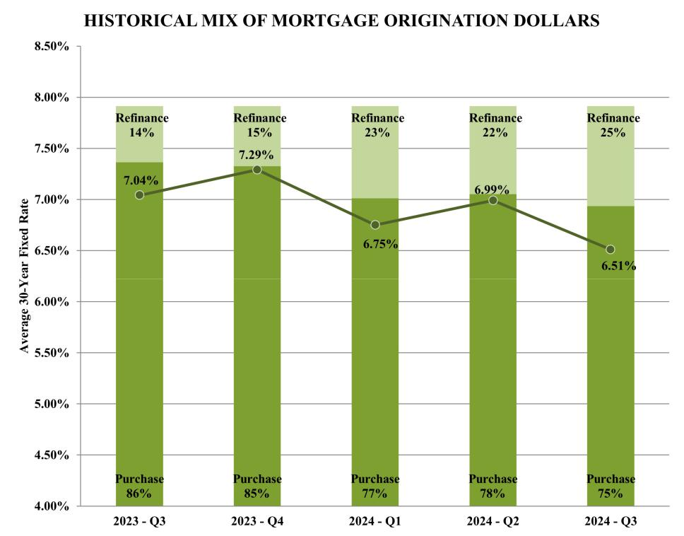

Typically, as mortgage interest rates rise, there are fewer consumers in the marketplace seeking refinancings and, accordingly, the mix of mortgage origination dollars will move toward purchase mortgages. According to Mortgage Bankers Association (“MBA”) data, total refinance origination dollars increased to 25% of total mortgage origination dollars in the third quarter of 2024 compared to 15% in the fourth quarter of 2023 and 14% in the third quarter of 2023. In the third quarter of 2024, total refinance origination dollars increased 135% from the fourth quarter of 2023 and increased 118% from the third quarter of 2023. Industry-wide mortgage origination dollars in the third quarter of 2024 increased 35% from the fourth quarter of 2023 and increased 21% from third quarter of 2023.

According to MBA projections, the mix of mortgage origination dollars is expected to continue to be weighted towards purchase mortgages with the refinance share representing approximately 28% for 2024 compared to 15% in 2023.

The U.S. Real Estate Market

The health of the U.S. real estate market and interest rate levels are the primary drivers of consumer demand for new mortgages. Consumer demand, in turn, affects lender demand for purchase mortgage leads from third-party sources. Typically, a strong real estate market will lead to reduced lender demand for leads, as there are more consumers in the marketplace seeking financing and, accordingly, lenders receive more organic lead volume. Conversely, a weaker real estate market will typically lead to an increase in lender demand, as there are fewer consumers in the marketplace seeking mortgages.

According to Fannie Mae data, existing home sales increased approximately 1% in the third quarter of 2024 compared to the fourth quarter of 2023, and decreased approximately 2% compared to the third quarter of 2023. Fannie Mae predicts an overall decrease in existing-home sales of approximately 1% in 2024 compared to 2023.

26

Table of Contents

SpringTM

We consider certain metrics related to LendingTree SpringTM ("Spring") set forth below to help us evaluate our business and growth trends and assess operational efficiencies. We believe our Spring platform drives repeat user engagement resulting in lower acquisition costs and increases consumer lifetime value. The calculation of the metrics discussed below may differ from other similarly titled metrics used by other companies, securities analysts or investors.

We added 1.2 million net new users in the third quarter of 2024, bringing cumulative active users to 30.7 million as of September 30, 2024. We calculate the number of Spring users at a period end as the number of users that had an active account at any point during the quarter that includes the period end date. Users that deactivated their accounts prior to the most recent quarter are no longer considered in the user base at the end of the most recent quarter. We attribute approximately $5.8 million of revenue, or 2% of total revenue, in the third quarter of 2024 to registered Spring users who initiated their transaction from the Spring platform. During the third quarter of 2024, approximately 0.3 million Spring users initiated a transaction from the Spring platform that contributed to revenue.

Cost Reductions and Simplification of Business

On March 24, 2023, we committed to a workforce reduction plan (the “Reduction Plan”), to reduce operating costs, which included the elimination of approximately 13% of our workforce. As a result of the Reduction Plan, we incurred approximately $5.3 million in severance charges in connection with the workforce reduction, $4.3 million of which was incurred in the first quarter of 2023 and $1.0 million was incurred in the second quarter of 2023. Part of this Reduction Plan included the shut down of our LendingTree customer call center as well as our Medicare insurance agency operations within QuoteWizard. We estimate the Reduction Plan reduced annual compensation expense by approximately $14 million, comprised of $2 million in cost of revenue, $4 million in selling and marketing expense, $3 million in general and administrative expense, and $5 million in product development.

Separately, in 2023, we made the decision to close our Ovation credit services business, an asset group within our Consumer segment, by mid- 2023. As a result, we recorded an asset impairment charge of $4.2 million in the first quarter of 2023 related to the write-off of certain long-term assets. Additionally, we incurred $2.1 million in severance charges in the second quarter of 2023 in connection with cash expenditures for employee separation costs. We acquired Ovation in 2018 to better serve those customers who come to LendingTree and receive suboptimal offers of credit. The business grew for a number of years before running into challenges in the wake of COVID-19, and more recently the industry has faced increased regulatory pressure. The business was capital-intensive, required elevated overhead, and future prospects were becoming uncertain.

The Ovation business accounted for approximately 3% of total revenue and 3% of total costs and expenses, with an immaterial impact to net income on the consolidated statement of operations and comprehensive income (loss) for the year ended December 31, 2022.

Regulations

Our revenue and earnings may fluctuate from time to time as a result of changes to federal, state, and industry-based laws and regulations, or changes to standards concerning the enforcement thereof. On January 26, 2024, the U.S. Federal Communications Commission (the “FCC”) published regulations which, among other things, amend the consent requirements of the Telephone Consumer Protection Act of 1991 to close what the FCC refers to as the “lead generator loophole” by requiring “one-to-one consent” for outbound telemarketing calls or texts made using an automatic telephone dialing system or pre-recorded or artificial voice messages to wireless or residential numbers. The new “one-to-one consent” rule is scheduled to take effect on January 27, 2025.

Although it remains unclear how these changes may ultimately be interpreted by courts or further revised by regulators, we anticipate that the required changes could have an adverse impact on the market for financial product and insurance quote requests and will require us and our third-party sources to modify our marketing practices and policies. While we have been proactively working to enhance our due diligence, contractual requirements, and oversight of lead generators, and will continue to analyze our marketing practices and policies and update as appropriate to mitigate the impact on our business and to ensure continuing compliance with the new rules, it is not possible to ensure that all lead generators and employees will comply with our policies and procedures at all times, which may result in potential litigation and regulatory exposure.

27

Table of Contents

Results of Operations for the Three and Nine Months ended September 30, 2024 and 2023

Our discussion within Revenue provides the details of consolidated revenue by segment and significant products. In this section, we describe overall changes in revenue in our segments and significant products within each segment and increases or decreases in revenue from the prior period. We also provide insight into how changes in price and volume in each significant product impacted product revenue.

Our Segment Profit is a discussion of profitability within each segment of the business. It is impacted by segment revenues as well as segment cost of revenue and marketing expenses. In Segment Profit, we provide a discussion of the business within each segment, addressing both Company and market impacts on the profitability of each segment in addition to a discussion of segment margin.

 |  |  | Three Months Ended September 30, |  |  |  |  |  |  |  | Nine Months Ended September 30,
 |  | 2024 |  | 2023 |  | $ | % |  |  | 2024 |  | 2023 |  | $ | %
 |  | 2024 |  | 2023 |  | Change | Change |  |  | 2024 |  | 2023 |  | Change | Change
 |  |  |  |  |  |  | (Dollars in thousands)
Home | $ | 32,248 | $ | 33,390 | $ | (1,142) | (3) % $ |  |  | 94,857 | $ | 118,628 | $ | (23,771) | (20) %
Consumer |  | 59,474 |  | 67,253 |  | (7,779) | (12) % |  |  | 166,826 |  | 229,439 |  | (62,613) | (27) %
Insurance |  | 169,065 |  | 54,536 |  | 114,529 | 210 % |  |  | 377,008 |  | 190,016 |  | 186,992 | 98 %
Other |  | 2 |  | 9 |  | (7) | (78) % |  |  | 6 |  | 66 |  | (60) | (91) %

Revenue |  | 260,789 |  | 155,188 |  | 105,601 | 68 % |  | 638,697 |  | 538,149 |  | 100,548 | 19 %
Costs and expenses:
Cost of revenue (exclusive of depreciation and |  | 9,372 |  | 7,570 |  | 1,802 | 24 | % | 26,328 |  | 30,632 |  | (4,304) | (14) %
amortization shown separately below) |  | 9,372 |  | 7,570 |  |  |  |  |  |  | 30,632 |  | (4,304) | (14) %
Selling and marketing expense |  | 193,542 |  | 97,244 |  | 96,298 | 99 | % | 450,105 |  | 350,420 |  | 99,685 | 28 %
General and administrative expense |  | 26,680 |  | 26,380 |  | 300 | 1 | % | 79,594 |  | 92,223 |  | (12,629) | (14) %
Product development |  | 11,190 |  | 10,840 |  | 350 | 3 | % | 33,421 |  | 36,096 |  | (2,675) | (7) %
Depreciation |  | 4,584 |  | 4,760 |  | (176) | (4) % |  | 13,852 |  | 14,239 |  | (387) | (3) %
Amortization of intangibles |  | 1,466 |  | 1,981 |  | (515) | (26) % |  | 4,422 |  | 6,012 |  | (1,590) | (26) %
Goodwill impairment |  | — |  | 38,600 |  | (38,600) | (100) % |  | — |  | 38,600 |  | (38,600) | (100) %
Restructuring and severance |  | 273 |  | 1,955 |  | (1,682) | (86) % |  | 498 |  | 9,967 |  | (9,469) | (95) %
Litigation settlements and contingencies |  | 3,762 |  | (150) |  | 3,912 | 2,608 | % | 3,791 |  | 350 |  | 3,441 | 983 %
Total costs and expenses |  | 250,869 |  | 189,180 |  | 61,689 | 33 % |  | 612,011 |  | 578,539 |  | 33,472 | 6 %
Operating income (loss) |  | 9,920 |  | (33,992) |  | 43,912 | 129 % |  | 26,686 |  | (40,390) |  | 67,076 | 166 %
Other income (expense), net:
Interest (expense) income, net |  | (10,060) |  | (7,097) |  | (2,963) | (42) % |  | (17,899) |  | 10,992 |  | (28,891) | (263) %
Other expense |  | (57,391) |  | (110,910) |  | 53,519 | 48 | % | (55,305) |  | (108,637) |  | 53,332 | 49 %
Loss before income taxes |  | (57,531) |  | (151,999) |  | 94,468 | 62 % |  | (46,518) |  | (138,035) |  | 91,517 | 66 %
Income tax (expense) benefit |  | (447) |  | 3,534 |  | 3,981 | 113 | % | (2,692) |  | 2,912 |  | 5,604 | 192 %
Net loss and comprehensive loss | $ | (57,978) | $ | (148,465) | $ | 90,487 | 61 % $ |  | (49,210) | $ | (135,123) | $ | 85,913 | 64 %

Revenue

Revenue increased in the third quarter and first nine months of 2024 compared to the third quarter and first nine months of 2023 due to increases in our Insurance segment partially offset by decreases in our Home and Consumer segments.

Our Consumer segment includes the following products: credit cards, personal loans, small business loans, student loans, auto loans, deposit accounts, and other credit products such as credit repair and debt settlement. The credit repair business was closed at the end of the second quarter of 2023. Many of our Consumer segment products are not individually significant to revenue. Revenue from our Consumer segment decreased $7.8 million, or 12%, in the third quarter of 2024 from the third quarter of 2023 primarily due to a decrease in credit cards, partially offset by increases in business loans and personal loans.

28

Table of Contents

Revenue from our Consumer segment decreased $62.6 million, or 27%, in the first nine months of 2024 from the first nine months of 2023 primarily due to decreases in each of our consumer products, primarily our credit cards and other credit products.

Revenue from our personal loans product increased $1.3 million, or 5%, to $27.8 million in the third quarter of 2024 from $26.5 million in the third quarter of 2023. The increase in revenue was due to a 31% increase in volume, representing $6.5 million , partially offset by a 20% decrease in revenue earned per consumer, representing $5.2 million. Revenue from our personal loans product decreased $3.4 million, or 4%, to $74.9 million in the first nine months of 2024 from $78.3 million in the first nine months of 2023. The decrease in revenue was due to an 18% decrease in revenue earned per consumer, representing $14.0 million of the decrease, partially offset by a 16% increase in volume, representing $10.6 million of an increase. We measure volume for our personal loans product as the number of unique consumers completing request forms.

For the current periods, no other products in our Consumer segment represented more than 10% of revenue; however, certain other Consumer products experienced notable changes. Revenue from our credit cards product decreased $8.5 million, or 58%, in the third quarter of 2024 compared to the third quarter of 2023 and decreased $34.6 million, or 64%, in the first nine months of 2024 compared to the first nine months of 2023 due to a decrease in volume and revenue earned per click. We measure volume for our credit cards product as the number of consumers clicking through to a card issuer. Revenue from our small business loans product increased $3.7 million, or 32%, in the third quarter of 2024 compared to the third quarter of 2023 primarily due to an increase in revenue earned per consumer. Revenue from our other credit products decreased $12.4 million, or 46%, in the first nine months of 2024 compared to the first nine months of 2023 due to the closure of our Ovation credit services business at the end of the second quarter of 2023. Revenue from our deposits product decreased $6.2 million or 45%, in the first nine months of 2024 compared to the first nine months of 2023 due to a decrease in volume and revenue earned per consumer.

Our Home segment includes the following products: purchase mortgage, refinance mortgage, and home equity loans and lines of credit. Revenue from our Home segment decreased $1.1 million, or 3%, in the third quarter of 2024 from the third quarter of 2023 primarily due to a decrease in mortgage products partially offset by an increase in our home equity loans product, and decreased $23.8 million, or 20%, in the first nine months of 2024 from the first nine months of 2023 due to decreases in revenue from each of our Home products.

Revenue from our mortgage products decreased $2.1 million, or 16%, to $11.2 million in the third quarter of 2024 from $13.3 million in the third quarter of 2023. The decrease in revenue was due to a 12% decrease in volume, representing $1.6 million of the decrease, and a 4% decrease in revenue earned per consumer, representing $0.5 million of the decrease.

Revenue from our mortgage products decreased $18.5 million, or 37%, to $31.1 million in the first nine months of 2024 from $49.5 million in the first nine months of 2023. The decrease in revenue was due to a 30% decrease in volume, representing $13.4 million of the decrease, and a 10% decrease in revenue earned per consumer, representing $5.1 million of the decrease. We measure volume for our mortgage products as the number of consumers completing request forms.

Revenue from our purchase mortgage product decreased $10.8 million in the first nine months of 2024 compared to the first nine months of 2023 primarily due to a decrease in the number of consumers completing request forms and a decrease in revenue earned per consumer. Revenue from our refinance mortgage product decreased $7.7 million in the first nine months of 2024 compared to the first nine months of 2023 due to a decrease in the number of consumers completing request forms and a decrease in revenue earned per consumer, as interest rates have risen.

Revenue from our home equity loans product decreased $5.3 million, or 8%, to $63.8 million in the first nine months of 2024 from $69.1 million in the first nine months of 2023. The decrease in revenue was due to a 19% decrease in revenue earned per consumer, representing $13.3 million of the decrease, partially offset by a 14% increase in volume, representing a $8.0 million increase. We measure volume for our home equity loans and lines of credit products as the number of consumers completing request forms.

Revenue from our Insurance segment increased $114.5 million, or 210%, to $169.1 million in the third quarter of 2024 from $54.5 million in the third quarter of 2023. The increase in revenue was due to a 107% increase in revenue earned per consumer, representing $58.1 million of the increase, and a 50% increase in volume, representing $56.4 million of the increase. Revenue from our Insurance segment increased $187.0 million, or 98%, to $377.0 million in the first nine months of 2024 from $190.0 million in the first nine months of 2023. The increase in revenue was due to a 54% increase in revenue earned per consumer, representing $102.3 million of the increase, and a 29% increase in volume, representing $84.7 million of the

29

Table of Contents

increase. We measure volume for our insurance product as the number of consumer request forms and in certain cases re-engagement with a consumer, the number of such subsequent consumer engagements through our platform.

Cost of revenue

Cost of revenue consists primarily of costs associated with compensation and other employee-related costs (including stock-based compensation) relating to internally-operated customer call centers, third-party customer call center fees, credit scoring fees, credit card fees, website network hosting, and server fees.

Cost of revenue increased $1.8 million in the third quarter of 2024 from the third quarter of 2023 primarily due to increases in direct costs associated with credit scoring and credit card fees, and compensation and benefits. Cost of revenue decreased $4.3 million in the first nine months of 2024 from the first nine months of 2023 primarily due to a decrease in compensation and benefits of $3.9 million. The decreases in the first nine months are primarily due to the Reduction Plan at the end of the first quarter of 2023, including shutting down the LendingTree customer call center, and the closure of the credit repair business at the end of the second quarter of 2023.

Cost of revenue as a percentage of revenue decreased to 4% in the third quarter of 2024 compared to 5% in the third quarter of 2023, and decreased to 4% in the first nine months of 2024 compared to 6% in the first nine months of 2023.

Selling and marketing expense

Selling and marketing expense consists primarily of advertising and promotional expenditures and compensation and other employee-related costs (including stock-based compensation) for personnel engaged in sales or marketing functions. Advertising and promotional expenditures primarily include online marketing, as well as television, print, and radio spending. Advertising production costs are expensed in the period the related ad is first run.

Selling and marketing expense increased in the third quarter of 2024 compared to the third quarter 2023 by $96.3 million, and increased $99.7 million in the first nine months of 2024 compared to the first nine months of 2023 primarily due to the changes in advertising and promotional expense discussed below. Additionally, compensation and benefits decreased $3.7 million in the first nine months of 2024 compared to the first nine months of 2023.

Advertising and promotional expense is the largest component of selling and marketing expense, and is comprised of the following:

 |  |  |  | Three Months Ended September 30, |  |  |  |  |  |  |  | Nine Months Ended September 30,
 |  | 2024 |  | 2023 |  | $ | % |  |  | 2024 |  | 2023 |  | $ | %
 |  | 2024 |  | 2023 |  | Change | Change |  |  | 2024 |  | 2023 |  | Change | Change
 |  |  |  |  |  |  | (Dollars in thousands)
Online | $ | 182,690 | $ | 86,524 | $ | 96,166 | 111 % |  | $ | 418,262 | $ | 311,598 | $ | 106,664 | 34 %
Broadcast |  | 17 |  | 61 |  | (44) | (72) % |  |  | 37 |  | 281 |  | (244) | (87) %
Other |  | 859 |  | 854 |  | 5 | 1 % |  |  | 2,835 |  | 5,917 |  | (3,082) | (52) %
Total advertising expense | $ | 183,566 | $ | 87,439 | $ | 96,127 | 110 % |  | $ | 421,134 | $ | 317,796 | $ | 103,338 | 33 %

In the periods presented, advertising and promotional expenses are equivalent to the non-GAAP measure variable marketing expense. See Variable Marketing Expense and Variable Marketing Margin below for additional information.

Revenue is primarily driven by Network Partner demand for our products, which is matched to corresponding consumer requests. We adjust our selling and marketing expenditures dynamically in relation to anticipated revenue opportunities in order to ensure sufficient consumer inquiries to profitably meet such demand. An increase in a product’s revenue is generally met by a corresponding increase in marketing spend, and conversely a decrease in a product’s revenue is generally met by a corresponding decrease in marketing spend. This relationship exists for our Home, Consumer, and Insurance segments.

We adjusted our advertising expenditures in the third quarter and first nine months of 2024 compared to the third quarter and first nine months of 2023 in response to changes in Network Partner demand on our marketplace. We will continue to adjust selling and marketing expenditures dynamically in response to anticipated revenue opportunities.

30

Table of Contents

General and administrative expense

General and administrative expense consists primarily of compensation and other employee-related costs (including stock-based compensation) for personnel engaged in finance, legal, tax, corporate information technology, human resources and executive management functions, as well as facilities and infrastructure costs and fees for professional services.

General and administrative expense remained relatively consistent in the third quarter of 2024 from the third quarter of 2023. General and administrative expense decreased in the first nine months of 2024 from the first nine months of 2023 primarily due to a decrease in compensation and benefits of $5.5 million, a decrease in fees and other charges of $1.5 million and a decrease in facilities expenses of $1.5 million. Additionally, we incurred a $4.2 million loss on the impairment of assets for our Ovation business in the first nine months of 2023.

General and administrative expense as a percentage of revenue decreased to 10% in the third quarter of 2024 compared to 17% in the third quarter of 2023, and decreased to 12% in the first nine months of 2024 compared to 17% in the first nine months of 2023.

Product development

Product development expense consists primarily of compensation and other employee-related costs (including stock-based compensation) and third-party labor costs that are not capitalized, for employees and consultants engaged in the design, development, testing and enhancement of technology.

Product development expense remained consistent in the third quarter of 2024 compared to the third quarter of 2023. Product development expense decreased in the first nine months of 2024 compared to the first nine months of 2023 primarily due to the Reduction Plan at the end of the first quarter of 2023. We continued to invest in internal development of new and enhanced features, functionality and business opportunities that we believe will enable us to better and more fully serve consumers and Network Partners.

Amortization of intangibles

The decrease in amortization of intangibles in the third quarter and first nine months of 2024 compared to the third quarter and first nine months of 2023 was primarily due to certain intangible assets associated with our recent business acquisitions becoming fully amortized.

Goodwill impairment

In the third quarter of 2023, we incurred a goodwill impairment charge of $38.6 million in our Insurance reporting unit. See Note 6 - Goodwill and Intangible Assets, in Part I. Item 1 Financial Statements, for additional information.

Restructuring and severance

During September 2023, we completed workforce reductions of 14 employees. We incurred approximately $0.9 million in severance charges in connection with the workforce reductions, consisting of cash expenditures for employee separation costs of approximately $0.7 million in the third quarter of 2023 and non-cash charges for the accelerated vesting of certain equity awards of approximately $0.2 million through the fourth quarter of 2023. The cash payments were completed by the third quarter of 2024.

On March 24, 2023, we committed to the Reduction Plan to reduce operating costs, which included the elimination of approximately 13% of our workforce. As a result of the Reduction Plan, we incurred approximately $5.3 million in severance charges in connection with the workforce reduction, consisting of cash expenditures for employee separation costs of approximately $4.3 million and non-cash charges for the accelerated vesting of certain equity awards of approximately $1.0 million. We incurred restructuring expense of $4.3 million in the first quarter of 2023 and an additional $1.0 million of restructuring expense in the second quarter of 2023 related to the Reduction Plan.

We made the decision to close the Ovation credit services business by mid-2023 and all operations ceased in August 2023. We incurred $2.1 million of restructuring expense related to the Ovation closure in the second quarter of 2023 in connection with cash expenditures for employee separation costs.

31

Table of Contents

Interest (expense) income

In March 2024, we drew $125.0 million on a first lien term loan facility and incurred $3.8 million and $8.0 million of interest expense in the third quarter of 2024 and first nine months of 2024, respectively.

In the third quarter of 2024, we repurchased approximately $7.6 million in principal amount of our 0.50% Convertible Senior Notes due July 15, 2025 (the "2025 Notes") for $7.2 million. As a result of the repurchase, we recognized a gain on the extinguishment of $0.5 million and an immaterial loss on the write-off of unamortized debt issuance costs, both of which are included in interest (expense) income, net in the consolidated statements of operations and comprehensive income.

In the second quarter of 2024, we repurchased approximately $161.3 million in principal amount of our 2025 Notes for $151.7 million plus accrued and unpaid interest of approximately $0.3 million. As a result of the repurchase, we recognized a gain on the extinguishment of $9.6 million and a loss on the write-off of unamortized debt issuance costs of $1.0 million, both of which are included in interest (expense) income, net in the consolidated statements of operations and comprehensive income.

In the first quarter of 2023, we repurchased approximately $190.6 million in principal amount of our 2025 Notes for $156.3 million plus accrued and unpaid interest of approximately $0.1 million. As a result of the repurchase, we recognized a gain on the extinguishment of $34.3 million, a loss on the write-off of unamortized debt issuance costs of $2.4 million, and incurred debt repayment costs of $1.0 million, all of which are included in interest (expense) income, net in the consolidated statements of operations and comprehensive income.

See Note 12—Debt, in Part I. Item 1 Financial Statements, for additional information.

Other expense

In the third quarter of 2024, we incurred impairment charges of $58.4 million related to two investments in equity securities.

In the third quarter of 2023, we incurred an impairment charge of $113.1 million related to an investment in equity securities.

See Note 7 - Equity Investment, in Part I. Item 1 Financial Statements, for additional information.

Income tax expense

For the third quarter and first nine months of 2024 and 2023, the effective tax rate varied from the federal statutory rate of 21% primarily due to the change in the valuation allowance, net of the current period change in tax effected net indefinite-lived intangibles.

32

Table of Contents

Segment Profit

 |  |  |  | Three Months Ended September 30, |  |  |  |  |  |  |  |  | Nine Months Ended September 30,
 |  | 2024 |  | 2023 |  | $ | % |  |  |  | 2024 |  | 2023 |  | $ | %
 |  | 2024 |  | 2023 |  | Change | Change |  |  |  | 2024 |  | 2023 |  | Change | Change
 |  |  |  |  |  |  | (Dollars in thousands)
Home
Revenue | $ | 32,248 | $ | 33,390 | $ | (1,142) | (3) % |  |  | $ | 94,857 | $ | 118,628 | $ | (23,771) | (20) %
Segment marketing expense ⁽¹⁾ |  | 22,993 |  | 22,095 |  | 898 | 4 | % |  | $ | 66,703 | $ | 78,878 | $ | (12,175) | (15) %
Segment profit | $ | 9,255 | $ | 11,295 | $ | (2,040) | (18) % |  |  | $ | 28,154 | $ | 39,750 | $ | (11,596) | (29) %
Segment margin |  | 29% |  | 34% |  |  |  |  |  |  | 30% |  | 34%
Consumer
Revenue |  | 59,474 |  | 67,253 |  | (7,779) | (12) % |  |  |  | 166,826 |  | 229,439 |  | (62,613) | (27) %
Segment marketing expense ⁽¹⁾ |  | 31,491 |  | 32,826 |  | (1,335) | (4) % |  |  |  | 84,491 |  | 119,466 |  | (34,975) | (29) %
Segment profit |  | 27,983 |  | 34,427 |  | (6,444) | (19) % |  |  |  | 82,335 |  | 109,973 |  | (27,638) | (25) %
Segment margin |  | 47% |  | 51% |  |  |  |  |  |  | 49% |  | 48%
Insurance
Revenue |  | 169,065 |  | 54,536 |  | 114,529 | 210 | % |  |  | 377,008 |  | 190,016 |  | 186,992 | 98 | %
Segment marketing expense ⁽¹⁾ |  | 127,622 |  | 31,177 |  | 96,445 | 309 | % |  |  | 265,751 |  | 111,754 |  | 153,997 | 138 | %
Segment profit |  | 41,443 |  | 23,359 |  | 18,084 | 77 | % |  |  | 111,257 |  | 78,262 |  | 32,995 | 42 | %
Segment margin |  | 25% |  | 43% |  |  |  |  |  |  | 30% |  | 41%
Other
Revenue |  | 2 |  | 9 |  | (7) | (78) % |  |  |  | 6 |  | 66 |  | (60) | (91) %
Segment marketing expense ⁽¹⁾ |  | 45 |  | 21 |  | 24 | 114 | % |  |  | 104 |  | 516 |  | (412) | (80) %
Other |  | (43) |  | (12) |  | (31) | (258) % |  |  |  | (98) |  | (450) |  | 352 | 78 | %
Total
Revenue |  | 260,789 |  | 155,188 |  | 105,601 | 68 | % |  |  | 638,697 |  | 538,149 |  | 100,548 | 19 | %
Segment marketing expense ⁽¹⁾ |  | 182,151 |  | 86,119 |  | 96,032 | 112 | % |  |  | 417,049 |  | 310,614 |  | 106,435 | 34 | %
Segment profit | $ | 78,638 | $ | 69,069 | $ | 9,569 | 14 % |  |  | $ | 221,648 | $ | 227,535 | $ | (5,887) | (3)%
Segment margin |  | 30% |  | 45% |  |  |  |  |  |  | 35% |  | 42%
⁽¹⁾Segment marketing expense represents the potion of selling and marketing expense attributable to variable costs paid for advertising, direct marketing and related expenses, that are directly attributable to the segments' products. This measure excludes overhead, fixed costs and personnel-related costs.

Segment profit is our primary segment operating metric. Segment profit is calculated as segment revenue less segment selling and marketing expenses attributed to variable costs paid for advertising, direct marketing and related expenses that are directly attributable to the segments' products. See Note 15—Segment Information in the notes to the consolidated financial statements for additional information on segments and a reconciliation of segment profit to pre-tax income.

Home

Home segment revenue decreased 3% to $32.2 million in the third quarter of 2024 from the third quarter of 2023 and segment profit decreased 18% to $9.3 million in the third quarter of 2024 from the third quarter of 2023. Segment margin declined to 29% in the third quarter of 2024 compared to 34% in the third quarter of 2023, primarily due to a decline in revenue earned per consumer, due to a decline in close rates at our lender partners.

Home equity revenue of $21.0 million in the third quarter of 2024 increased $0.9 million from $20.1 million in the third quarter of 2023. Volume of home equity consumers completing request forms increased 25% in the third quarter of 2024

33

Table of Contents

compared to the third quarter of 2023, however, a 17% decline in revenue earned per consumer partially offset this volume growth.

Within Home, our core mortgage business generated revenue of $11.2 million in the third quarter of 2024, down 16% from the third quarter of 2023. Our refinance product within our mortgage business matches consumers in the market looking to refinance their existing mortgages with our network lenders. Our purchase product within our mortgage business matches consumers in the market looking to buy a new home with our network lenders. Our mortgage business is directly impacted by the mortgage market in which we participate. Our mortgage business continues to see headwinds from a lack of in-the-money refinance borrowers given the current higher level of mortgage rates, and subdued home sales have pressured the volume of consumers searching for purchase loans.

We believe financial market expectations for continued decreases in interest rates may benefit the mortgage and home equity lending environment and our Home segment. Consumer

Our Consumer segment revenue decreased 12% to $59.5 million in the third quarter of 2024 from the third quarter of 2023, and segment profit decreased 19% to $28.0 million in the third quarter of 2024 from the third quarter of 2023 due to the decline in revenue. Segment margin was 47% in the third quarter of 2024 compared to 51% in the third quarter of 2023 primarily due to a decline in revenue earned per consumer on certain products as well as a change in mix shift in the product revenue.

Personal loans revenue of $27.8 million in the third quarter of 2024 increased 5% from the third quarter of 2023 as lending standards remain restrictive at our lender partners. If financial market expectations for decreases in short-term interest rates remain as projected, we believe this would likely benefit our personal loans product in future quarters.

Small business revenue increased 32% in the third quarter of 2024 from the third quarter of 2023, as the lending appetite has remained stable from our partners. Additionally, the revenue growth has allowed us to invest more into marketing spend to capture high quality business owners searching for loans.

See the section titled "Revenue" above for additional discussion of declines in product revenues within the Consumer segment.

Insurance

Insurance revenue increased 210% to $169.1 million in the third quarter of 2024 from the third quarter of 2023 and segment profit increased 77% to $41.4 million in the third quarter of 2024 from the third quarter of 2023. Carrier demand for new auto insurance customers has been strong, with volume increasing 50% in the third quarter of 2024 compared to the third quarter of 2023, as two years of compounded premium rate increases combined with declines in the price of used vehicles and replacement parts has created a favorable underwriting environment.

Segment margin declined to 25% in the third quarter of 2024 from 43% in the third quarter of 2023. In 2023, we were able to exit from our highest cost marketing channels and continue to meet the decreased level of demand. In 2024, we re-entered those marketing channels to fill the increase in carrier demand, which has resulted in lower segment profit margin.

Variable Marketing Expense and Variable Marketing Margin

We report variable marketing expense and variable marketing margin as supplemental measures to accounting principles generally accepted in the United States of America ("GAAP".) These related measures are the primary metrics by which we measure the effectiveness of our marketing efforts. Variable marketing expense represents the portion of selling and marketing expense attributable to variable costs paid for advertising, direct marketing, and related expenses, and excludes overhead, fixed costs, and personnel-related expenses. Variable marketing margin is a measure of the efficiency of our operating model, measuring revenue after subtracting variable marketing expense. Our operating model is highly sensitive to the amount and efficiency of variable marketing expenditures, and our proprietary systems are able to make rapidly changing decisions concerning the deployment of variable marketing expenditures (primarily but not exclusively online and mobile advertising placement) based on proprietary and sophisticated analytics. We believe that investors should have access to the same set of tools that we use in analyzing our results. This non-GAAP measure should be considered in addition to results prepared in accordance with GAAP but should not be considered a substitute for or superior to GAAP results. We provide and encourage investors to examine the reconciling adjustments between the GAAP and non-GAAP measures discussed below.

34

Table of Contents

Variable marketing expense is defined as the expense attributable to variable costs paid for advertising, direct marketing and related expenses, and excluding overhead, fixed costs and personnel-related expenses. The majority of these variable advertising costs are expressly intended to drive traffic to our websites and these variable advertising costs are included in selling and marketing expense on our consolidated statements of operations and comprehensive income. Variable marketing margin is defined as revenue less variable marketing expense.

The following shows the calculation of variable marketing margin:

 |  | Three Months Ended |  |  |  |  | Nine Months Ended
 |  | September 30, |  |  |  |  | September 30,
 |  | 2024 |  | 2023 |  |  | 2024 |  | 2023
 |  |  |  | (in thousands)
Revenue | $ | 260,789 | $ | 155,188 |  | $ | 638,697 | $ | 538,149
Variable marketing expense |  | 183,566 |  | 87,439 |  |  | 421,134 |  | 317,796
Variable marketing margin | $ | 77,223 | $ | 67,749 |  | $ | 217,563 | $ | 220,353

Below is a reconciliation of selling and marketing expense, the most directly comparable GAAP measure, to variable marketing expense:

 |  | Three Months Ended |  |  |  |  | Nine Months Ended
 |  | September 30, |  |  |  |  | September 30,
 |  | 2024 |  | 2023 |  |  | 2024 |  | 2023
 |  |  |  | (in thousands)
Selling and marketing expense | $ | 193,542 | $ | 97,244 |  | $ | 450,105 | $ | 350,420
Non-variable selling and marketing expense |  | (9,976) |  | (9,805) |  |  | (28,971) |  | (32,624)
Variable marketing expense | $ | 183,566 | $ | 87,439 |  | $ | 421,134 | $ | 317,796

The following is a reconciliation of net loss, the most directly comparable GAAP measure, to variable marketing margin:

 |  | Three Months Ended |  |  |  |  | Nine Months Ended
 |  | September 30, |  |  |  |  | September 30,
 |  | 2024 |  | 2023 |  |  | 2024 |  | 2023
 |  |  |  | (in thousands)
Net loss | $ | (57,978) | $ | (148,465) |  | $ | (49,210) | $ | (135,123)
Adjustments to reconcile to variable marketing margin:
Cost of revenue |  | 9,372 |  | 7,570 |  |  | 26,328 |  | 30,632
Non-variable selling and marketing expense ⁽¹⁾ |  | 9,976 |  | 9,805 |  |  | 28,971 |  | 32,624
General and administrative expense |  | 26,680 |  | 26,380 |  |  | 79,594 |  | 92,223
Product development |  | 11,190 |  | 10,840 |  |  | 33,421 |  | 36,096
Depreciation |  | 4,584 |  | 4,760 |  |  | 13,852 |  | 14,239
Amortization of intangibles |  | 1,466 |  | 1,981 |  |  | 4,422 |  | 6,012
Goodwill impairment |  | — |  | 38,600 |  |  | — |  | 38,600
Restructuring and severance |  | 273 |  | 1,955 |  |  | 498 |  | 9,967
Litigation settlements and contingencies |  | 3,762 |  | (150) |  |  | 3,791 |  | 350
Interest expense (income), net |  | 10,060 |  | 7,097 |  |  | 17,899 |  | (10,992)
Other expense |  | 57,391 |  | 110,910 |  |  | 55,305 |  | 108,637
Income tax expense (benefit) |  | 447 |  | (3,534) |  |  | 2,692 |  | (2,912)
Variable marketing margin | $ | 77,223 | $ | 67,749 |  | $ | 217,563 | $ | 220,353

- Represents the portion of selling and marketing expense not attributable to variable costs paid for advertising, direct marketing and related expenses. Includes overhead, fixed costs and personnel-related expenses.

35

Table of Contents

Adjusted EBITDA

We report Adjusted EBITDA as a supplemental measure to GAAP. This measure is the primary metric by which we evaluate the performance of our businesses, on which our marketing expenditures and internal budgets are based and by which, in most years, management and many employees are compensated. We believe that investors should have access to the same set of tools that we use in analyzing our results. This non-GAAP measure should be considered in addition to results prepared in accordance with GAAP but should not be considered a substitute for or superior to GAAP results. We provide and encourage investors to examine the reconciling adjustments between the GAAP and non-GAAP measures discussed below.

Definition of Adjusted EBITDA

We report Adjusted EBITDA as net income adjusted to exclude interest, income tax, amortization of intangibles and depreciation, and to further exclude (1) non-cash compensation expense, (2) non-cash impairment charges, (3) gain/loss on disposal of assets, (4) gain/loss on investments, (5) restructuring and severance expenses, (6) litigation settlements and contingencies, (7) acquisitions and dispositions income or expense (including with respect to changes in fair value of contingent consideration), (8) contributions to the LendingTree Foundation, (9) dividend income, and (10) one-time items. Adjusted EBITDA has certain limitations in that it does not take into account the impact to our statement of operations of certain expenses, including depreciation, non-cash compensation and acquisition-related accounting. We endeavor to compensate for the limitations of the non-GAAP measures presented by also providing the comparable GAAP measures with equal or greater prominence and descriptions of the reconciling items, including quantifying such items, to derive the non-GAAP measures. These non-GAAP measures may not be comparable to similarly titled measures used by other companies.

One-Time Items

Adjusted EBITDA is adjusted for one-time items, if applicable. Items are considered one-time in nature if they are non-recurring, infrequent, or unusual and have not occurred in the past two years or are not expected to recur in the next two years, in accordance with SEC rules. For the periods presented below, there are no adjustments for one-time items.

Non-Cash Expenses that are Excluded from Adjusted EBITDA

Non-cash compensation expense consists principally of expense associated with grants of restricted stock, restricted stock units and stock options, some of which awards have performance-based vesting conditions. Non-cash compensation expense also includes expense associated with employee stock purchase plans. These expenses are not paid in cash, and we include the related shares in our calculations of fully diluted shares outstanding. Upon settlement of restricted stock units, exercise of certain stock options or vesting of restricted stock awards, the awards may be settled, on a net basis, with us remitting the required tax withholding amount from our current funds.

Amortization of intangibles are non-cash expenses relating primarily to intangible assets acquired through acquisitions. At the time of an acquisition, the intangible assets of the acquired company, such as purchase agreements, technology and customer relationships, are valued and amortized over their estimated lives.

36

Table of Contents

The following table is a reconciliation of net loss, the most directly comparable GAAP measure, to Adjusted EBITDA.

 |  | Three Months Ended |  |  |  |  | Nine Months Ended
 |  | September 30, |  |  |  |  | September 30,
 |  | 2024 |  | 2023 |  |  | 2024 |  | 2023
 |  |  |  | (in thousands)
Net loss | $ | (57,978) | $ | (148,465) |  | $ | (49,210) | $ | (135,123)
Adjustments to reconcile to Adjusted EBITDA:
Amortization of intangibles |  | 1,466 |  | 1,981 |  |  | 4,422 |  | 6,012
Depreciation |  | 4,584 |  | 4,760 |  |  | 13,852 |  | 14,239
Restructuring and severance |  | 273 |  | 1,955 |  |  | 498 |  | 9,967
Loss on impairments and disposal of assets |  | 6 |  | 88 |  |  | 787 |  | 5,255
Loss on impairment of equity investments |  | 58,376 |  | 113,064 |  |  | 58,376 |  | 114,504
Goodwill impairment |  | — |  | 38,600 |  |  | — |  | 38,600
Non-cash compensation expense |  | 6,859 |  | 8,592 |  |  | 22,085 |  | 28,999
Acquisition expense |  | — |  | — |  |  | — |  | (5)
Litigation settlements and contingencies |  | 3,762 |  | (150) |  |  | 3,791 |  | 350
Interest expense (income), net |  | 10,060 |  | 7,097 |  |  | 17,899 |  | (10,992)
Dividend income |  | (982) |  | (2,154) |  |  | (3,241) |  | (5,867)
Income tax expense (benefit) |  | 447 |  | (3,534) |  |  | 2,692 |  | (2,912)
Adjusted EBITDA | $ | 26,873 | $ | 21,834 |  | $ | 71,951 | $ | 63,027

Financial Condition, Liquidity and Capital Resources

General

As of September 30, 2024, we had $96.8 million of cash and cash equivalents, compared to $112.1 million of cash and cash equivalents as of December 31, 2023.

In the third quarter of 2024, we repurchased approximately $7.6 million in principal amount of our 2025 Notes for $7.2 million. As a result of the repurchase, we recognized a gain on the extinguishment of $0.5 million and an immaterial loss on the write-off of unamortized debt issuance costs, both of which are included in interest (expense) income, net in the consolidated statements of operations and comprehensive income.

In the second quarter of 2024, we repurchased approximately $161.3 million in principal amount of our 2025 Notes for $151.7 million plus accrued and unpaid interest of approximately $0.3 million. As a result of the repurchase, we recognized a gain on the extinguishment of $9.6 million and a loss on the write-off of unamortized debt issuance costs of $1.0 million, both of which are included in interest (expense) income, net in the consolidated statements of operations and comprehensive income.

We expect our cash and cash equivalents, cash flows from operations and available borrowings under our credit facilities to be sufficient to fund our operating needs for the next twelve months and beyond. We will continue to monitor the impact of the current economic conditions, including interest rates and inflation on our liquidity and capital resources.

As of September 30, 2024, we have $115.3 million outstanding on the 2025 Notes. We intend to use cash on hand, available borrowings of $50.0 million from the 2024 Term Loan (as defined below), and future cash flows from operations for the repayment of the 2025 Notes.

37

Table of Contents

Equity Distribution Agreement

In July 2024, we entered into an Equity Distribution Agreement in connection with the establishment of an ATM Equity Program (as defined in the 2024 Term Loan (as defined herein) agreement) under which we may sell up to an aggregate of $50.0 million of shares of the our common stock. No sales were made under the Equity Distribution Agreement during the three months ended September 30, 2024.

Credit Facilities

On September 15, 2021, we entered into a credit agreement (the “Credit Agreement”), consisting of a $200.0 million revolving credit facility (the “Revolving Facility”), which matures on September 15, 2026, and a $250.0 million delayed draw term loan facility (the “2021 Term Loan” and together with the Revolving Facility, the “Credit Facility”), which matures on September 15, 2028. The proceeds of the Revolving Facility can be used to finance working capital, for general corporate purposes and any other purpose not prohibited by the Credit Agreement. We borrowed $250.0 million under the delayed draw term loan on May 31, 2022 and used $170.2 million of the proceeds to settle our 0.625% Convertible Senior Notes due June 1, 2022 ("2022 Notes"), including interest. The remaining proceeds of $79.8 million may be used for general corporate purposes and any other purposes not prohibited by the Credit Agreement.

As of November 1, 2024, we have outstanding $244.4 million under the 2021 Term Loan and the remaining borrowing capacity under the Revolving Facility is $200.0 million. As of September 30, 2024, we have $20.0 million available for borrowing under the Revolving Facility.

On March 27, 2024, we entered a first lien term loan facility (the “2024 Term Loan”), consisting of $175.0 million which matures on March 27, 2031. We drew $125.0 million of the 2024 Term Loan upon closing while the remaining $50.0 million will be available as a delayed draw term loan until March 27, 2025. The proceeds of the 2024 Term Loan were used to pay fees and expenses incurred in connection with the closing of the 2024 Term Loan and delayed draw term loan, and will be used for working capital and general corporate purposes, which may include repayment of our 2025 Notes. The funding had a $3.1 million original issue discount and associated debt issuance costs of $4.3 million.

We filed an ATM Shelf Registration (as defined in the 2024 Term Loan agreement) with the SEC in the third quarter of 2024. In the event of a default in the minimum Consolidated EBITDA (as defined in the 2024 Term Loan agreement) covenant in the 2024 Term Loan, we are required to utilize the ATM Equity Program (as defined in the 2024 Term Loan agreement) to sell common stock and use the proceeds to cure the event of default in the minimum Consolidated EBITDA covenant. Additionally, we may use the ATM Equity Program to maintain the $40.0 million minimum cash balance requirement in the 2024 Term Loan.

As of November 1, 2024, we had $118.8 million borrowings outstanding under the 2024 Term Loan.

See Note 12—Debt, in Part I. Item 1 Financial Statements, for additional information.

Cash Flows

Our cash flows are as follows:

Nine Months Ended
September 30,

 |  | 2024 |  | 2023
 |  | (in thousands)
Net cash provided by operating activities | $ | 46,022 | $ | 46,692
Net cash used in investing activities |  | (8,396) |  | (9,928)
Net cash used in financing activities |  | (52,894) |  | (160,150)

Cash Flows from Operating Activities

Our largest source of cash provided by our operating activities is revenues generated by our products. Our primary uses of cash from our operating activities include advertising and promotional payments. In addition, our uses of cash from operating activities include compensation and other employee-related costs, other general corporate expenditures, litigation settlements and contingencies, and income taxes.

38

Table of Contents

Net cash provided by operating activities remained relatively consistent in the first nine months of 2024 from the first nine months of 2023 primarily due to unfavorable changes in accounts receivable, partially offset by favorable changes in accounts payable, accrued expenses and other current liabilities.

Cash Flows from Investing Activities

Net cash used in investing activities in the first nine months of 2024 and 2023 consisted of capital expenditures primarily related to internally developed software.

Cash Flows from Financing Activities

Net cash used in financing activities in the first nine months of 2024 consisted primarily of the repurchase of the 2025 Notes for $158.8 million, term loan repayments of $8.8 million and $2.8 million in withholding taxes paid upon surrender of shares to satisfy obligations on equity awards, net of proceeds from the exercise of stock options offset by $117.8 million net proceeds from the 2024 Term Loan.

Net cash used in financing activities in the first nine months of 2023 consisted primarily of the repurchase of the 2025 Notes for $156.3 million.

New Accounting Pronouncements and Critical Accounting Estimates

For information regarding new accounting pronouncements and critical accounting estimates, see Note 2—Significant Accounting Policies, in Part I, Item 1 Financial Statements.

Item 3. Quantitative and Qualitative Disclosures about Market Risk

We are exposed to market risks as a result of changes to interest rates.

Interest Rate Risk

Other than our Credit Facility and the 2024 Term Loan, we do not have any financial instruments that are exposed to significant market risk. We maintain our cash and cash equivalents in bank deposits and short-term, highly liquid money market investments. A hypothetical 100-basis point increase or decrease in market interest rates would not have a material impact on the fair value of our cash equivalents securities, or our earnings on such cash equivalents, but would have a $2.4 million annual effect on the interest paid on borrowings under the Credit Facility and a $1.2 million annual effect on the interest paid on borrowings under the 2024 Term Loan. As of November 1, 2024, the Company had $244.4 million outstanding on its 2021 Term Loan, and there were no outstanding borrowings under its Revolving Facility. As of November 1, 2024, the Company had $118.8 million outstanding on its 2024 Term Loan, which was entered into on March 27, 2024.

Fluctuations in interest rates affect consumer demand for new mortgages and the level of refinancing activity which, in turn, affects lender demand for mortgage leads. Typically, when interest rates decline, we see increased consumer demand for mortgage refinancing, which in turn leads to increased traffic to our website and decreased selling and marketing efforts associated with that traffic. At the same time, lender demand for leads from third-party sources typically decreases, as there are more consumers in the marketplace seeking refinancings and, accordingly, lenders receive more organic lead volume. Due to lower lender demand, our revenue earned per consumer typically decreases but with correspondingly lower selling and marketing costs. Conversely, when interest rates increase, we typically see decreased consumer demand for mortgage refinancing, leading to decreased traffic to our website and higher associated selling and marketing efforts associated with that traffic. At the same time, lender demand for leads from third-party sources typically increases, as there are fewer consumers in the marketplace and, accordingly, the supply of organic mortgage lead volume decreases. Due to high lender demand, we typically see an increase in the amount lenders will pay per matched lead, which often leads to higher revenue earned per consumer. However, increases in the amount lenders will pay per matched lead in this situation is limited by the overall cost models of our lenders, and our revenue earned per consumer can be adversely affected by the overall reduced demand for refinancing in a rising rate environment.

39

Table of Contents

Item 4. Controls and Procedures

Evaluation of Disclosure Controls and Procedures

As required by Rule 13a-15(b) of the Securities Exchange Act of 1934, as amended (the “Exchange Act”), management, with the participation of our principal executive officer (our Chief Executive Officer) and principal financial officer (our Chief Financial Officer), evaluated, as of the end of the period covered by this report, the effectiveness of our disclosure controls and procedures. The term “disclosure controls and procedures,” as defined in Rules 13a-15(e) and 15d-15(e) under the Exchange Act, means controls and other procedures of a company that are designed to ensure that information required to be disclosed by a company in the reports that it files under the Exchange Act is recorded, processed, summarized and reported, within the time periods specified in the SEC’s rules and forms. Disclosure controls and procedures include, without limitation, controls and procedures designed to ensure that information required to be disclosed by a company in the reports that it files under the Exchange Act is accumulated and communicated to a company’s management, including its principal executive officer and principal financial officer, as appropriate to allow timely decisions regarding required disclosure. Based upon that evaluation, our Chief Executive Officer and Chief Financial Officer concluded that our disclosure controls and procedures are effective, as of September 30, 2024, to reasonably ensure that information required to be disclosed and filed under the Exchange Act is recorded, processed, summarized and reported within the time periods specified, and that management will be timely alerted to material information required to be included in our periodic reports filed with the Securities and Exchange Commission.

Changes in Internal Control Over Financial Reporting

There was no change in our internal control over financial reporting that occurred during the quarter ended September 30, 2024 that has materially affected, or is reasonably likely to materially affect, our internal controls over financial reporting.

40

Table of Contents

PART II—OTHER INFORMATION

Item 1. Legal Proceedings

In the ordinary course of business, we are party to litigation involving property, contract, intellectual property, data privacy and security, and a variety of other claims. The amounts that may be recovered in such matters may be subject to insurance coverage. On or about October 29, 2019, Joseph Mantha filed a class action lawsuit against QuoteWizard.com, LLC alleging claims in violation of the Telephone Consumer Protection Act. On August 16, 2024, the U.S. District Court of Massachusetts granted the plaintiff’s motion to certify a class. This case is set for mediation on November 13, 2024.

In addition to the foregoing, we have provided information about certain legal proceedings in which we are involved in Part I, Item 3. Legal Proceedings of our 2023 Annual Report and updated that information in Note 13—Contingencies to the consolidated financial statements included elsewhere in this Quarterly Report on Form 10-Q.

Item 1A. Risk Factors

Risk factors that affect our business and financial results are discussed in Part I, Item 1A "Risk Factors," in our 2023 Annual Report. There have been no material changes to the risk factors included in our 2023 Annual Report.

You should carefully consider the risks described in our 2023 Annual Report, which could materially affect our business, financial condition or future results. The risks described in our 2023 Annual Report are not the only risks we face. Additional risks and uncertainties not currently known to us or that we currently deem to be immaterial also may materially adversely affect our business, financial condition, and/or operating results. If any of the risks actually occur, our business, financial condition, and/or results of operations could be negatively affected.

Item 2. Unregistered Sales of Equity Securities and Use of Proceeds

Issuer Purchases of Equity Securities

In each of February 2018 and February 2019, the board of directors authorized and we announced a stock repurchase program which allowed for the repurchase of up to $100.0 million and $150.0 million, respectively, of our common stock. Under this program, we can repurchase stock in the open market or through privately-negotiated transactions. We have used available cash to finance these repurchases. We will determine the timing and amount of any additional repurchases based on our evaluation of market conditions, applicable SEC guidelines and regulations, and other factors. This program may be suspended or discontinued at any time at the discretion of our board of directors. Our 2024 Term Loan limits stock repurchases. During the quarter ended September 30, 2024, no shares of common stock were repurchased under the stock repurchase program. As of November 1, 2024, approximately $96.7 million remains authorized for share repurchase.

Additionally, the LendingTree 2023 Stock Plan and LendingTree 2023 Inducement Grant Plan allows employees to elect for us to withhold (or take back, with respect to restricted stock awards) shares of our common stock to satisfy federal and state withholding obligations upon the exercise of stock options, the settlement of restricted stock unit awards and the vesting of restricted stock awards granted to those individuals under the plans. During the quarter ended September 30, 2024, 10,714 shares were withheld related to these obligations under the LendingTree 2023 Stock Plan. The withholding of those shares does not affect the dollar amount or number of shares that may be purchased under the stock repurchase program described above.

41

Table of Contents

The following table provides information about the Company's purchases of equity securities during the quarter ended September 30, 2024.

 |  |  |  |  |  |  |  | Total Number of |  |  |  | Approximate
 |  |  |  |  |  |  |  | Shares Purchased as |  |  |  | Dollar Value of Shares
 |  | Total Number of |  |  | Average Price |  |  | Part of Publicly |  |  |  | that May Yet Be
Period |  |  |  |  | Average Price |  |  | Announced Plans or |  |  |  | Purchased Under the
 |  | Shares Purchased (1) |  |  | Paid per Share |  |  | Programs (2) |  |  |  | Plans or Programs
 |  |  |  |  |  |  |  |  |  |  |  | (in thousands)
7/1/2024 - 7/31/2024 |  | 851 |  | $ |  | 41.17 |  |  | — |  | $ | 96,655
8/1/2024 - 8/31/2024 |  | 4,111 |  | $ |  | 47.91 |  |  | — |  | $ | 96,655
9/1/2024 - 9/30/2024 |  | 5,752 |  | $ |  | 57.42 |  |  | — |  | $ | 96,655
Total |  | 10,714 |  | $ |  | 52.48 |  |  | — |  | $ | 96,655

- During July 2024, August 2024 and September 2024, 851 shares, 4,111 shares and 5,752 shares, respectively (totaling 10,714 shares), were purchased to satisfy federal and state withholding obligations of our employees upon the settlement of restricted stock units and the exercise of stock options, all in accordance with our 2023 Stock Plan, as described above.

- See the narrative disclosure above the table for further description of our publicly announced stock repurchase program.

Item 5. Other Information

During the fiscal quarter ended September 30, 2024, none of the Company's directors or executive officers adopted or terminated any contract, instruction or written plan for the purchase or sale of Company securities that was intended to satisfy the affirmative defense conditions of Rule 10b5-1(c) or any "non-Rule 10b5-1 trading arrangement." Further, during the fiscal quarter ended September 30, 2024, the Company did not adopt or terminate a Rule 10b5-1 trading arrangement.

42

Table of Contents

Item 6. Exhibits

Exhibit |  | Description |  |  |  |  |  |  |  |  | Location
3.1 | Amended and Restated Certificate of Incorporation of LendingTree, Inc. |  |  |  |  |  |  |  |  |  | Exhibit 3.1 to the Registrant's Current Report on
 |  |  |  |  |  |  |  |  |  |  | Form 8-K filed August 25, 2008
3.2 | Fourth Amended and Restated By-laws of LendingTree, Inc. |  |  |  |  |  |  |  |  |  | Exhibit 3.1 to the Registrant's Current Report on
 |  |  |  |  |  |  |  |  |  |  | Form 8-K filed November 15, 2017
10.1 | First Amendment to Credit Amendment, dated as of September 25, 2024, by and among the Company, the lenders party |  |  |  |  |  |  |  |  |  | †
 | thereto, Apollo Administrative Agency, as administrative agent and collateral agent.
31.1 | Certification of the Chief Executive Officer pursuant to Rule 13a-14(a) or Rule 15d-14(a) of the Securities Exchange Act of |  |  |  |  |  |  |  |  |  | †
 | 1934 as adopted pursuant to Section 302 of the Sarbanes-Oxley Act of 2002.
31.2 | Certification of the Chief Financial Officer pursuant to Rule 13a-14(a) or Rule 15d-14(a) of the Securities Exchange Act of |  |  |  |  |  |  |  |  |  | †
 | 1934 as adopted pursuant to Section 302 of the Sarbanes-Oxley Act of 2002.
32.1 | Certification of the Chief Executive Officer pursuant to 18 U.S.C. Section 1350 as adopted pursuant to Section 906 of the |  |  |  |  |  |  |  |  |  | ††
 | Sarbanes-Oxley Act of 2002.
32.2 | Certification of the Chief Financial Officer pursuant to 18 U.S.C. Section 1350 as adopted pursuant to Section 906 of the |  |  |  |  |  |  |  |  |  | ††
 | Sarbanes-Oxley Act of 2002.
101.INS | XBRL Instance Document — The instance document does not appear in the Interactive Data File because its XBRL tags are |  |  |  |  |  |  |  |  |  | †††
 | embedded within the Inline XBRL document.
101.SCH | XBRL Taxonomy Extension Schema Document |  |  |  |  |  |  |  |  |  | †††
101.CAL | XBRL Taxonomy Extension Calculation Linkbase Document |  |  |  |  |  |  |  |  |  | †††
101.DEF | XBRL Taxonomy Extension Definition Linkbase Document |  |  |  |  |  |  |  |  |  | †††
101.LAB | XBRL Taxonomy Extension Label Linkbase Document |  |  |  |  |  |  |  |  |  | †††
101.PRE | XBRL Taxonomy Extension Presentation Linkbase Document |  |  |  |  |  |  |  |  |  | †††
104 | Cover Page Interactive Data File (embedded within the Inline XBRL document contained in Exhibit 101) |  |  |  |  |  |  |  |  |  | †††

________________________________________________________________________________________________________________________________

† Filed herewith.

- Furnished herewith. This certification is being furnished solely to accompany this report pursuant to 18 U.S.C. 1350, and is not being filed for purposes of Section 18 of the Exchange Act and is not to be incorporated by reference into any filing of the registrant, whether made before or after the date hereof, regardless of any general incorporation language in such filing.

- Furnished herewith. Pursuant to Rule 406T of Regulation S-T, the Interactive Data Files on Exhibit 101 hereto are deemed not filed or part of a registration statement or prospectus for purposes of Sections 11 or 12 of the Securities Act of 1933, as amended, are deemed not filed for purposes of Section 18 of the Exchange Act, and otherwise are not subject to liability under those sections.

43

Table of Contents

SIGNATURE

Pursuant to the requirements of the Securities Exchange Act of 1934, the registrant has duly caused this report to be signed on its behalf by the undersigned thereunto duly authorized.

Date: November 1, 2024

LENDINGTREE, INC.

By: /s/ JASON BENGEL

Jason Bengel

Chief Financial Officer

(principal financial officer and duly authorized officer)

44

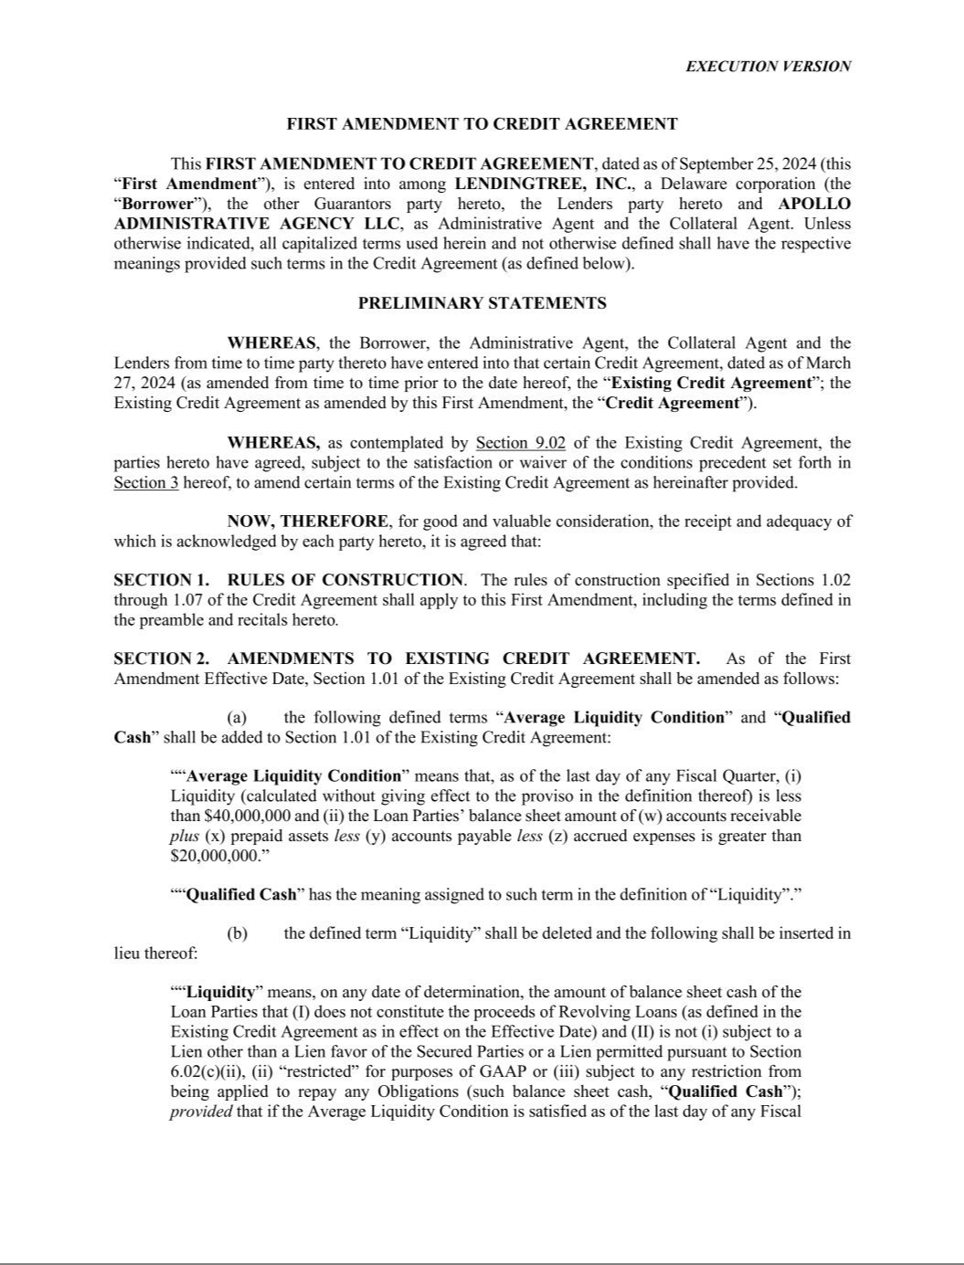

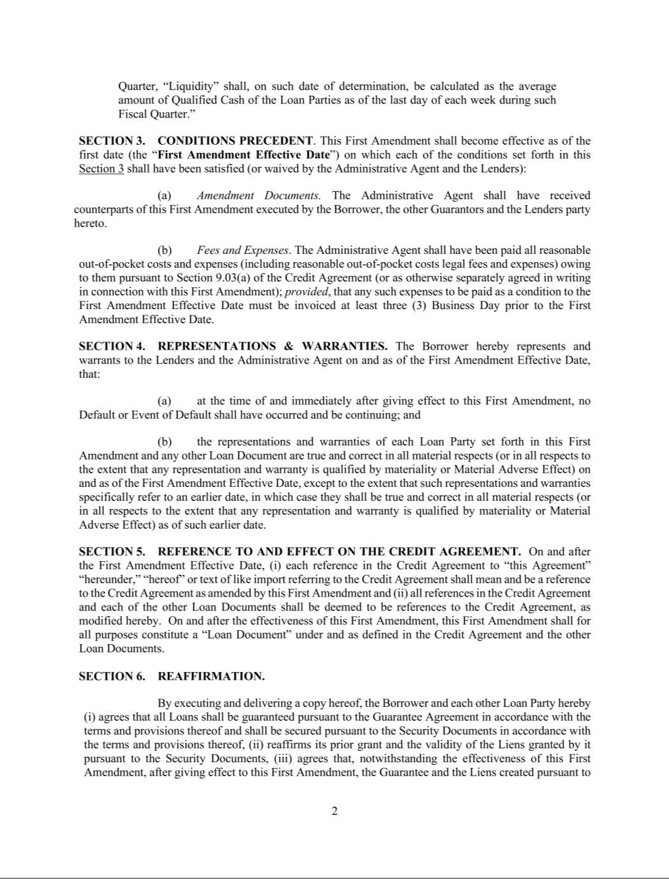

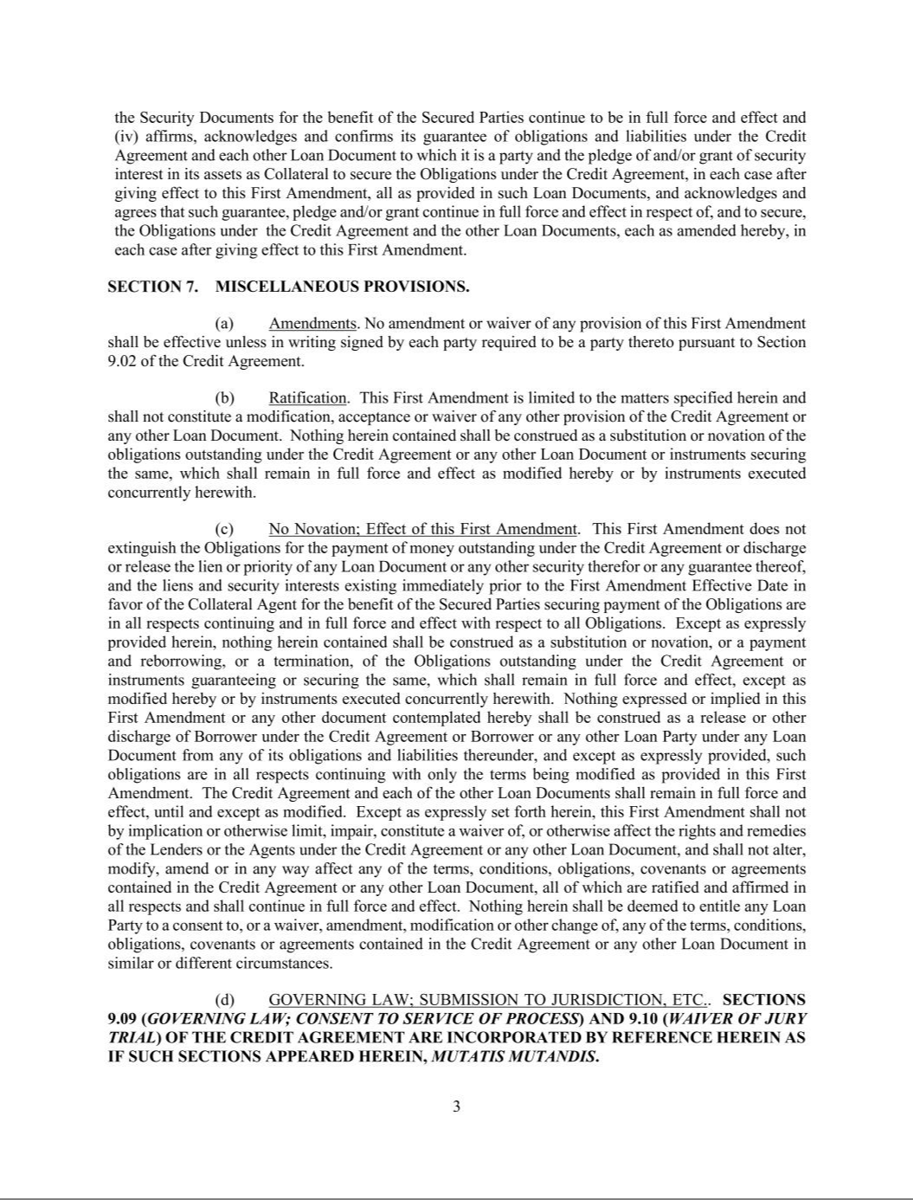

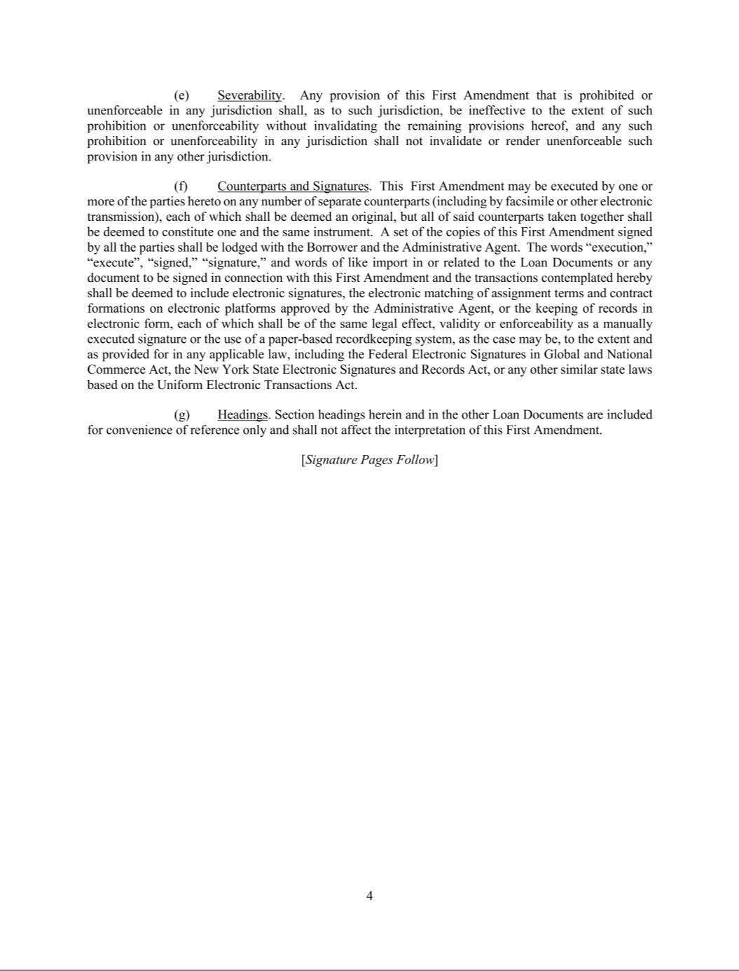



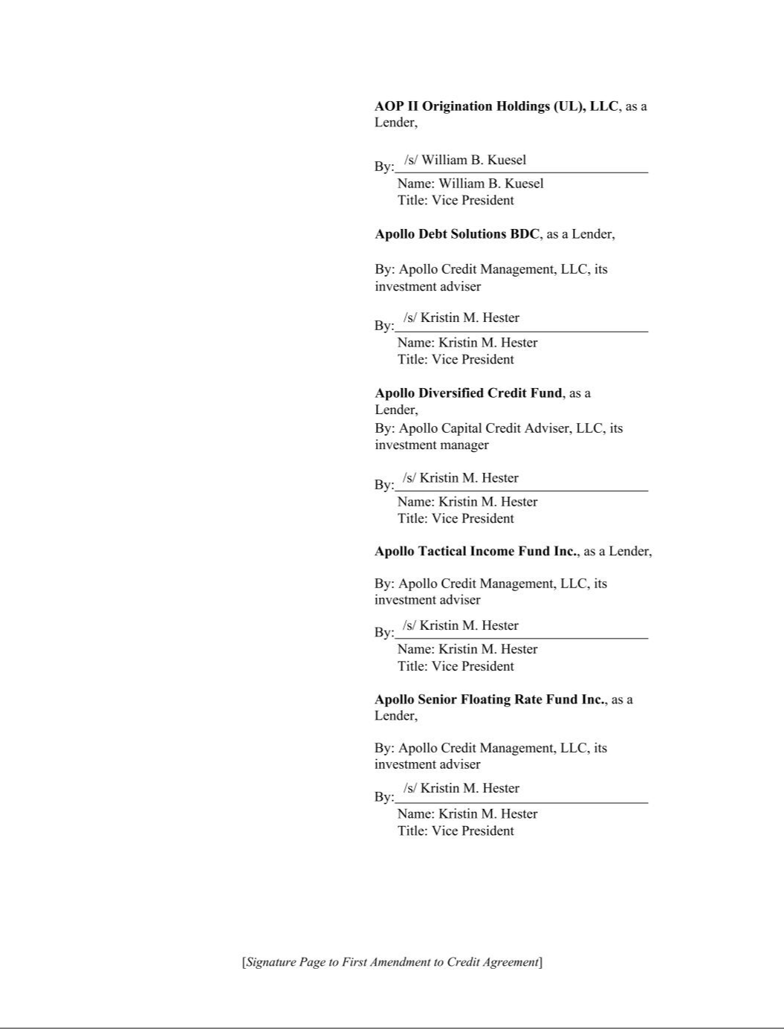

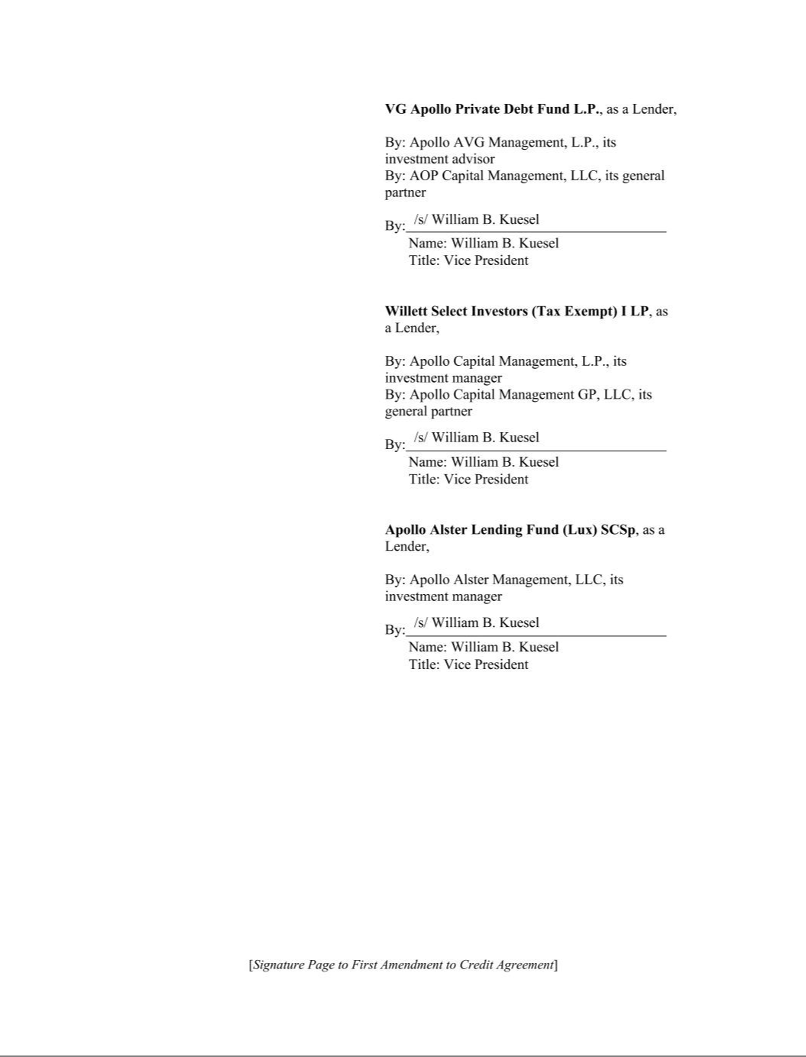

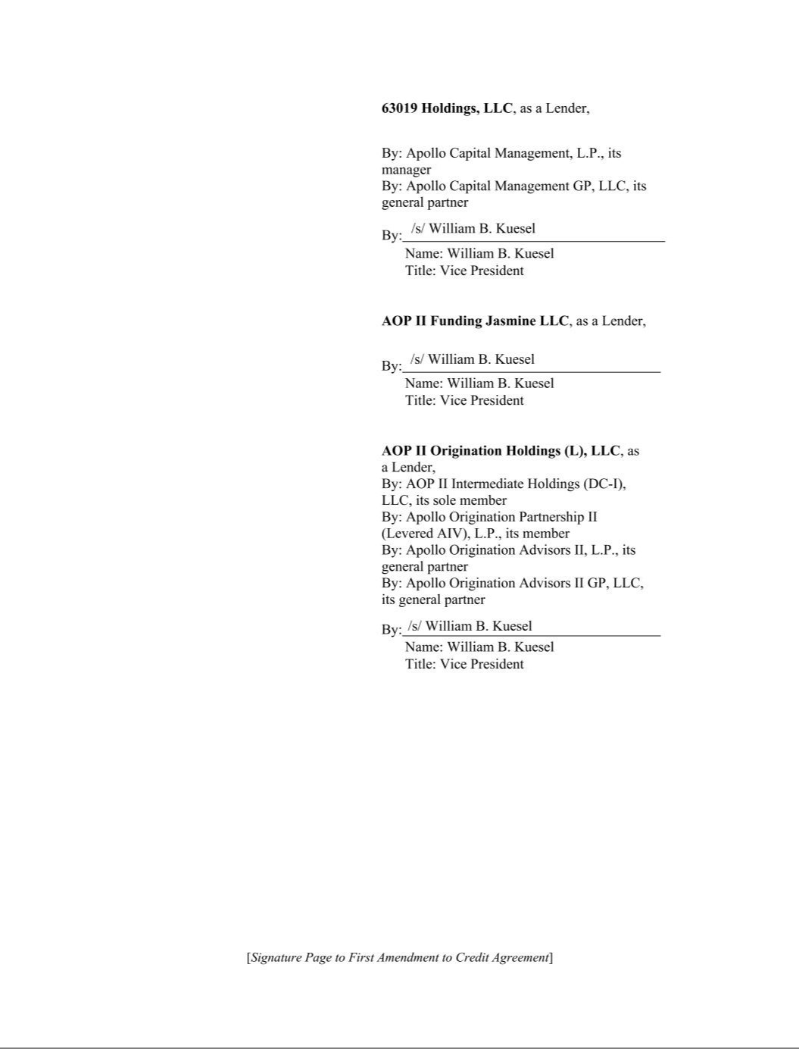



Exhibit 31.1

CERTIFICATION

I, Douglas R. Lebda, certify that:

- I have reviewed this quarterly report on Form 10-Q for the period ended September 30, 2024 of LendingTree, Inc.;

- Based on my knowledge, this report does not contain any untrue statement of a material fact or omit to state a material fact necessary to make the statements made, in light of the circumstances under which such statements were made, not misleading with respect to the period covered by this report;

- Based on my knowledge, the financial statements, and other financial information included in this report, fairly present in all material respects the financial condition, results of operations and cash flows of the registrant as of, and for, the periods presented in this report;

- The registrant’s other certifying officer(s) and I are responsible for establishing and maintaining disclosure controls and procedures (as defined in Exchange Act Rules 13a-15(e) and 15d-15(e)) and internal control over financial reporting (as defined in Exchange Act Rules 13a-15(f) and 15d-15(f)) for the registrant and have:

  - Designed such disclosure controls and procedures, or caused such disclosure controls and procedures to be designed under our supervision, to ensure that material information relating to the registrant, including its consolidated subsidiaries, is made known to us by others within those entities, particularly during the period in which this report is being prepared;

  - Designed such internal control over financial reporting, or caused such internal control over financial reporting to be designed under our supervision, to provide reasonable assurance regarding the reliability of financial reporting and the preparation of financial statements for external purposes in accordance with generally accepted accounting principles;

  - Evaluated the effectiveness of the registrant’s disclosure controls and procedures and presented in this report our conclusions about the effectiveness of the disclosure controls and procedures, as of the end of the period covered by this report based on such evaluation; and

  - Disclosed in this report any change in the registrant’s internal control over financial reporting that occurred during the registrant’s most recent fiscal quarter (the registrant’s fourth fiscal quarter in the case of an annual report) that has materially affected, or is reasonably likely to materially affect, the registrant’s internal control over financial reporting; and

- The registrant’s other certifying officer(s) and I have disclosed, based on our most recent evaluation of internal control over financial reporting, to the registrant’s auditors and the audit committee of the registrant’s board of directors (or persons performing the equivalent functions):

  - All significant deficiencies and material weaknesses in the design or operation of internal control over financial reporting which are reasonably likely to adversely affect the registrant’s ability to record, process, summarize and report financial information; and

  - Any fraud, whether or not material, that involves management or other employees who have a significant role in the registrant’s internal control over financial reporting.

Date: November 1, 2024

/s/ Douglas R. Lebda

Douglas R. Lebda

Chairman and Chief Executive Officer

(principal executive officer)

Exhibit 31.2

CERTIFICATION

I, Jason Bengel, certify that:

- I have reviewed this quarterly report on Form 10-Q for the period ended September 30, 2024 of LendingTree, Inc.;

- Based on my knowledge, this report does not contain any untrue statement of a material fact or omit to state a material fact necessary to make the statements made, in light of the circumstances under which such statements were made, not misleading with respect to the period covered by this report;

- Based on my knowledge, the financial statements, and other financial information included in this report, fairly present in all material respects the financial condition, results of operations and cash flows of the registrant as of, and for, the periods presented in this report;

- The registrant’s other certifying officer(s) and I are responsible for establishing and maintaining disclosure controls and procedures (as defined in Exchange Act Rules 13a-15(e) and 15d-15(e)) and internal control over financial reporting (as defined in Exchange Act Rules 13a-15(f) and 15d-15(f)) for the registrant and have:

  - Designed such disclosure controls and procedures, or caused such disclosure controls and procedures to be designed under our supervision, to ensure that material information relating to the registrant, including its consolidated subsidiaries, is made known to us by others within those entities, particularly during the period in which this report is being prepared;

  - Designed such internal control over financial reporting, or caused such internal control over financial reporting to be designed under our supervision, to provide reasonable assurance regarding the reliability of financial reporting and the preparation of financial statements for external purposes in accordance with generally accepted accounting principles;

  - Evaluated the effectiveness of the registrant’s disclosure controls and procedures and presented in this report our conclusions about the effectiveness of the disclosure controls and procedures, as of the end of the period covered by this report based on such evaluation; and

  - Disclosed in this report any change in the registrant’s internal control over financial reporting that occurred during the registrant’s most recent fiscal quarter (the registrant’s fourth fiscal quarter in the case of an annual report) that has materially affected, or is reasonably likely to materially affect, the registrant’s internal control over financial reporting; and

- The registrant’s other certifying officer(s) and I have disclosed, based on our most recent evaluation of internal control over financial reporting, to the registrant’s auditors and the audit committee of the registrant’s board of directors (or persons performing the equivalent functions):

  - All significant deficiencies and material weaknesses in the design or operation of internal control over financial reporting which are reasonably likely to adversely affect the registrant’s ability to record, process, summarize and report financial information; and

  - Any fraud, whether or not material, that involves management or other employees who have a significant role in the registrant’s internal control over financial reporting.

Date: November 1, 2024

/s/ Jason Bengel

Jason Bengel

Chief Financial Officer

(principal financial officer)

Exhibit 32.1

CERTIFICATION OF THE PRINCIPAL EXECUTIVE OFFICER

PURSUANT TO 18 U.S.C. SECTION 1350,

AS ADOPTED PURSUANT TO

SECTION 906 OF THE SARBANES-OXLEY ACT OF 2002

I, Douglas R. Lebda, certify, pursuant to 18 U.S.C. Section 1350, as adopted pursuant to Section 906 of the Sarbanes-Oxley Act of 2002, that to my knowledge:

- the Quarterly Report on Form 10-Q for the fiscal quarter ended September 30, 2024 of LendingTree, Inc. (the “Report”) which this statement accompanies fully complies with the requirements of Section 13(a) or 15(d) of the Securities Exchange Act of 1934 (15 U.S.C. 78m or 78o(d)); and

- the information contained in the Report fairly presents, in all material respects, the financial condition and results of operations of LendingTree, Inc.

Date: November 1, 2024

/s/ Douglas R. Lebda

Douglas R. Lebda

Chairman and Chief Executive Officer

(principal executive officer)

Exhibit 32.2

CERTIFICATION OF THE PRINCIPAL FINANCIAL OFFICER

PURSUANT TO 18 U.S.C. SECTION 1350,

AS ADOPTED PURSUANT TO

SECTION 906 OF THE SARBANES-OXLEY ACT OF 2002

I, Jason Bengel, certify, pursuant to 18 U.S.C. Section 1350, as adopted pursuant to Section 906 of the Sarbanes-Oxley Act of 2002, that to my knowledge:

- the Quarterly Report on Form 10-Q for the fiscal quarter ended September 30, 2024 of LendingTree, Inc. (the “Report”) which this statement accompanies fully complies with the requirements of Section 13(a) or 15(d) of the Securities Exchange Act of 1934 (15 U.S.C. 78m or 78o(d)); and

- the information contained in the Report fairly presents, in all material respects, the financial condition and results of operations of LendingTree, Inc.

Date: November 1, 2024

/s/ Jason Bengel

Jason Bengel

Chief Financial Officer

(principal financial officer)

